**PREFACE**

Today’s world is computer world because most of the work is doing with the help of computer. Dependency on computer is behind the few reasons. We cannot easily manage to store large number of data or information single handle. If we need some information or data in urgency then we cannot manage in manually these works are very difficult if we cannot use computers.

My website on **AUTOMATED TELLER MACHINE** provide a perfect environment for online booking of tables. The Restaurant Management is a web based application which would be used to provide online support to the restaurant owner and also the customers. The web application would be much more helpful to get the information about the charges availability of tables, hostel address etc. The management would fell that their good will has increased by providing such an online application in market.

The project report provides all the detail view of the software **AUTOMATED TELLER MACHINE**. From my point of view there is no further system or subsystem explained else where this project report contains the introduction, objective, purpose scope, project perspective, product feature, hardware and software requirement, front end and backend tool process logic, logic diagram, data flow diagram, ER diagram, database detail and database structure and bibliography.

I have exerted a conscious effort make website user oriented and user friendly. I hope the users would find the website not only interested but also useful.

DIPALI SHARMA

BCA V SEM

17072010063

**ACKNOWLEDGEMENT**

Fifth semester project is a minor component of academics schedule of B.C.A. Hence I worked on **AUTOMATED TELLER MACHINE**. The conceptual knowledge acquired by management/computer student is best manified in the project. I wish to greatfully acknowledge my indebateness to my teachers whose keen intelact invaluable suggestions, his presence with my never endind queries made it possible for me to learn so much and complete this project. Their generous help and missionary zeal where a source of input, outstrength to my whole developing the system.

I express my whole hearted gratitude towards Sherwood College of Professional Management for giving me the opportunity to undergo my project in the field of website development of great report and allowing me gain invaluable experience. I express my heart – felt gratitute to Miss. Vinita Mishra for guiding me during the project period. I also express my special thank to all the staff who gave me their precious time and help me whenever required. I am thankful to my parents who has always been supportive in my correct decision and giving me useful advice. I also express my sincere thank to all respodants without whose help completion of this project is not possible.

**TABLE OF CONTENT**

Tiltle of the project………………………………………………………………….

Introduction & Objective of the Project…………………………………..

Tools/ Enviroment Used…………………………………………………………..

1. Feasibility Study…………………………………………………………….
2. Problem Definition…………………………………………………………
3. Project Scheduling………………………………………………………….
4. Data Flow Diagram………………………………………………………….

Complete Structure……………………………………………………………………

1. Modules and their descprtion…………………………………………..
2. Data structure…………………………………………………………………..
3. Process logic of the modules……………………………………………..
4. List of reports generated……………………………………………………

Project Code………………………………………………………………………………..

Testing………………………………………………………………………………………….

Project Screenshot…………………………………………………………………………

Implementation of Security……………………………………………………………

Future scope and enhancement……………………………………………………..

Conclusion……………………………………………………………………………………….

PROJECT REPORT

**TABLE OF CONTENTS**

**1. INTRODUCTION**

1.1 Background

1.2 Objectives

1.3 Purpose and Scope

1.3.1 Purpose

1.3.2 Scope

**2. SURVEY OF TECHNOLOGIES**

**3. REQUIREMENTS AND ANALYSIS**

3.1 Problem Definition

3.2 Planning and Scheduling

3.3 Requirements Specification

3.3.1 Software

3.3.2 Hardware

3.4 Preliminary Product Description

3.5 Conceptual Models

**4. References**

**1.Introduction**

**1.1 Background:-**

We are very glad to introduce our minor project “**AUTOMATED TELLER MACHINE**”. Now a day each company or organization prefers the computerized paper-work. Definitely the computer system is more reliable than the manual works. The common human errors can be eliminated with the help of system.

An **Automated Teller Machine** (**ATM**) is a computerized telecommunications device that provides the customers of a financial institution with access to financial transaction in a public space without the need for a human clerk or bank teller. On most modern ATMs, the customer is identified by inserting a plastic ATM card with a magnetic stripe or a plastic smartcard with a chip that contains a unique card number and some security information.

ATMs are known by various other names including automated banking machine, money machine, bank machine, cash machine and Any Time Money in World.

An ATM card (also known as a bank card, client card, key card or cash card) is an ISO 7810 card issued by a bank, credit union or building society, Unlike a debit card, in-store purchases or refunds with an ATM card can generally be made in person only, as they require authentication through a personal identification number (PIN) and One Time Password in users Phone number. In other words, ATM cards cannot be used at merchants that only accept credit cards.

**1.2 Objective :-**

This application would help very much keeping record about all customers, their personal information, whole transaction which they have performed in a given

duration etc. All the record would be kept in a database and which would be available on just a single click.

Every branch would be able to know about how many accounts were opened in a given duration, how many fixed deposits were done etc. It becomes very much easy for the management to generate customized reports on the basis of their requirement.

**1.3 Purpose and Scope :-**

**1.3.1 Purpose:-**

The system is designed keeping in mind the current requirements of the ATM. However some aspects were not considered and system can easily changing where shop requirements are changed.

Some of the enhancements can be:

* System can be design in GUI environment.
* System can be design to work without manpower by using Scratch card.
* The system can be made flexible so that new modules can be added at any given time.
* In future system can be construct the modules of Loan Information, Mobile recharge, Pay electricity bill can be developed.

**1.3.2 Scope:-**

As this is software it can be used by a wide variety of banks to automate the process of manually maintaining the records related to the each transaction of

bank account holder. The main goal of this application is to provide very reliable & efficient service to bank account holder at any time & any location.

**This system will cover mainly two Modules, i.e.**

* **Admin.**
* **Customer(Account Holder).**
* **Admin Module will cover Five Sub modules,**

a. Opening Account.

b. Modify Account.

c. View Particular Transaction.

d. View Account.

e. View All Transaction.

* **Customer Module will cover Eight Sub modules,**

1. Cash Withdrawal.
2. Balance Enquiry.
3. Mini Statement.
4. PIN Change.
5. Cash Deposit.
6. Transfer Fund.
7. Mobile Registration.
8. Fast Cash Withdrawal.

**2.SURVEY AND TECHNOLOGIES:-**

**2.1 Introduction of MySQL**:-

MySQL,a Relational Database Management System (RDBMS), works to efficiently manage its resource, a database of information, among the multiple clients requesting and sending data in the network. SQL SERVER has many important features that make it not only an exceptional database management system but also an excellent database server choice for client/server database computing. Here are some of these features:

1. The reasons to choose it as back-end are:

1.1 It is very simple to maintain.

1.2 It is highly secured.

1.3 It can be integrated with Microsoft Visual Basic very easily.

1.4 It can support and manage a large amount of data.

1.5 It is a very scalable product and can support as many number of users as 1.f supported by the infrastructure.

1.g Supports all major operating systems for both clients and servers, including MS-DOS, NETWARE, WINDOWS, NT MATCH OS/2 and UNIX.

**2.2 Introduction of Java:-**

Sun Micro System Company Started As:-

“*Java is Simple, Object Oriented, Platform Independent(Architectural Neural),Multi-Threaded, Robust, Secure, Portable, Compiled and Interpreted, Distributed, High Performance & Dynamic Programming Language.*”

Features of Java:-

**1.Simple:-**

Java follows almost syntax of C and C++ that’s why it can learn by C and C++ Programmer easily.

**2.Object Oriented:-**

As we know that C++ is partially object oriented programming language that support some concept of OOP’s Language.

For Example:- In C++ we can write program without class and object.But in java without class and object we can not use any statement.

Java Supports All Features of Object Oriented Programming.

**3. Platform Independent:-**

A Java Application can run on any Operating System without making any change.

(.javac) java compiler covert a source code file into byte code (.java) & (.class) file & this byte file can run on any operating system using java interpreter(java).

**4. Multi-Threading:-**

Multi-Threading is a programming approach that improves the performance of an application & software by maximum ultilization of CPU.

In multi threading a large programs can be divided into independent part of program and each part of a program is called or known as thread.

Now these thread can be executed simultaneously by the CPU to improve the performance.

**5. Robust:-**

A java software does not permits to aquire entire memory of computer system.

So a java application can not be cause of data crash. Another example of robustness that java does not allow input from user without exception handling.

**6. Secure:-**

Java does not support pointer, destructor and operator overloading due to security reason. Another example of security that java. Contain class security manager which is used to apply inbuilt security for java application.

**7. Portable:-**

Java byte code are lightest weight that takes minimum memory that’s why it can move from one machine to another machine by network. So it is called portable.

**8. Compiled & Interpreted:-**

Java uses both the mechanism of compiler and interpreter. Thats why it is called compiled and interpreted programming language.

**9. Distributed:-**

A java software can run easily and effectively on a network. Thats why it is called distributed programming language.

**10 .High Performance:-**

Java Uses JIT Compiler(Just In Time) this compiler is responsible for conversion of byte code to machine code and execution of program simultaneously.

So, JIT Compiler reduces waiting time of conversion byte code to machine code make java programming application make faster execution.

**11.Dynamic:-**

As we know that in C/C++ by default Memory Allocation for variable will proceed at the time of compilation but in java all variable allocates memory at the time of execution.

i.e., dynamic memory allocation it is a reason that’s why java we can declare variable any where in a program.

Java Software/Environment

A java environment can be classified into two types:-

**1. JDK(Java Development Kit):-**

It is responsible compilation of java program.after the compilation of java program it creates byte code file.

1. **JRE(Java RunTime Environment):-**

It is responsible for the execution of program and JRE contains JVM(Java Virtual Machine) and JVM contains JIT(Just In Time) Compiler.

Classification of Java Technology:-

Java Technology comes into 3 flavors:-

**1. J2ME(Java 2 Micro Edition):-**

It is used to development of application for electronic embedded system.

For e.g:-Remote, ATMs, Smart TV, Washing Machine etc.

**2. J2SE(Java 2 Standard Edition):-**

It is used to development window based application that can run on a small distributed network. i.e. LAN(Local Area Network).

For e.g.:- Accounting software for a company

Attendance Automation

Billing Application for a store or Gaming Application

**3. J2EE(Java 2 Enterprise Edition):-**

It is used to develop application for a large distributed network such as internet.

for e.g.:- Online Banking, Railway Reservation System, Online Examination etc.

**Types of Java Programs:-**

**1. Application Program:-**

It is similar to C/C++ program that contain a main method, usual compiler starts execution from this main method. In industry it also known as Core Java Application.

**2. Applet:-**

An Applet is pure GUI(Graphical User Interface) program which is useds for dynamic animation using applet programming we develop gamming application.

Applet programming is common in J2SE & J2EE.

**3. Servlet:-**

Servlet is a server site program that always run under the web server and it is used to develop web page application.

**3. REQUIREMENT AND ANALYSIS**

**3.1 Problem Definition:-**

**Automated Teller Machine** (**ATM**) system is banking software developed to give facility of bank customer for 24hours & nearer to your location, therefore customer can do their transaction at any time at any place. This software is also help for bank, to minimize crowding of customer in bank premises & pressure of work on bank servants.

Now a day each company or organization prefers the computerized paper-work. Definitely the computer system is more reliable than the manual works. The common human errors can be eliminated with the help of system.

The main objective of ATM system is to help the organization in automating the whole manual processing of the existing system. This project should support multi user environment. The system is fully automated. ATM systemis designed to solve the purpose of clarifying system requirement. This system should be able to handle extremely large volumes of data. This system should capable to keep track of all detailed description of the account holder of banks.

**The following details are involved in this ATM system project,**

* Admin/Open and Manage Account/View Daily Transactions.
* ATM Card holder /account /bank customer detail.
* Daily transaction detail of each ATM card holder.

**Existing System:-**

* Existing system creates complexity in doing calculation of collection of

money because it is manual.

* Existing system creates problems in maintaining records of book keeping.
* Existing system, there is large documentary work so it requires space for its

storage.

* To do the documentary work there is need of extra staff worker.
* Existing system takes much more time to updating process of records.

Due to existing system crowding of customer in bank premises are more &

pressure of work on bank servants are also more.

**Need for the new system:-**

* The proposed system need to maintain all the records in computerized form.
* It is useful to store record systematically & accurately by using this system.
* It is useful to reducing the extra work which maintains the records of book keeping & paper less work.
* We can easily handle data efficiently & effectively.The storage space, extra workers, missing files all these possibilities are decreased through this system.

This system helps to save time & cost spending on documentation.

* With the help of this system ATM card holder can see all the records about his account only at any time efficiently.
* The most important facility provided by this system is that, there is no any possibility of miss any records.
* This system is useful for recording daily transactions done by customers.

So, this system helps to overcome the problems of previous system.

* An ATM card is an ISO card issued by a bank, credit union or building society. Unlike a debit card, in-store purchases or refunds with an ATM card can generally be made in person only, as they require authentication through a personal identification number or PIN. In other words, ATM cards cannot be used at merchants that only accept credit cards.

**DFD (DATA FLOW DIAGRAM):-**

Designing of this software is done with high cohesiveness i.e. there is minimum interaction between two different modules. There is no intra modular relationship between modules. Most of the modules are self-independent. At same time modules are loosely coupled i.e. inter modular relation exists.

Designing part includes its data flow diagrams, Database Tables and process logic of each and every modules, input design and output design. Input design includes input screens such as Business Login screen, Business Registration Screen, Unit Creation Screen, Unit Operator Creation Screen, Session Creation Screen, Session Termination Screen and many more for Transaction and output design includes Output screens such as Business Details, Unit Details, Unit Operator Details and various reports.

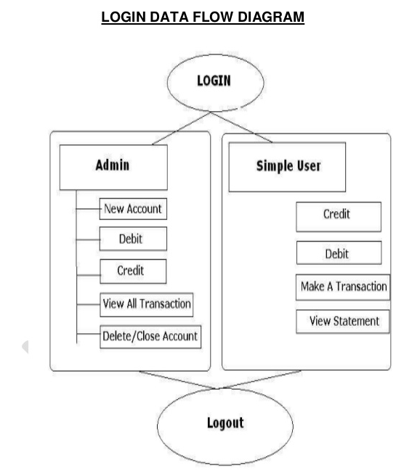**1. DFD**

**Zero Level DFD**

**ER DIAGRAM**

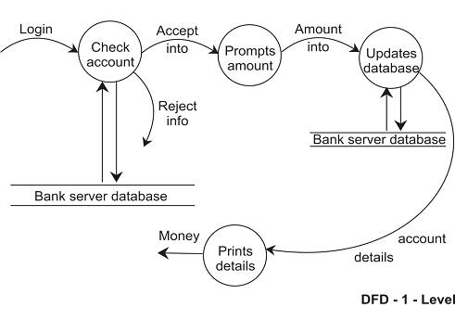

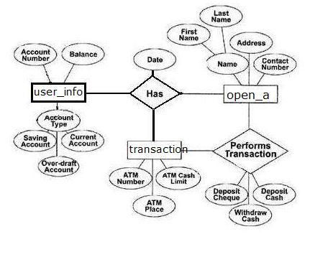

**Admin Table:-**

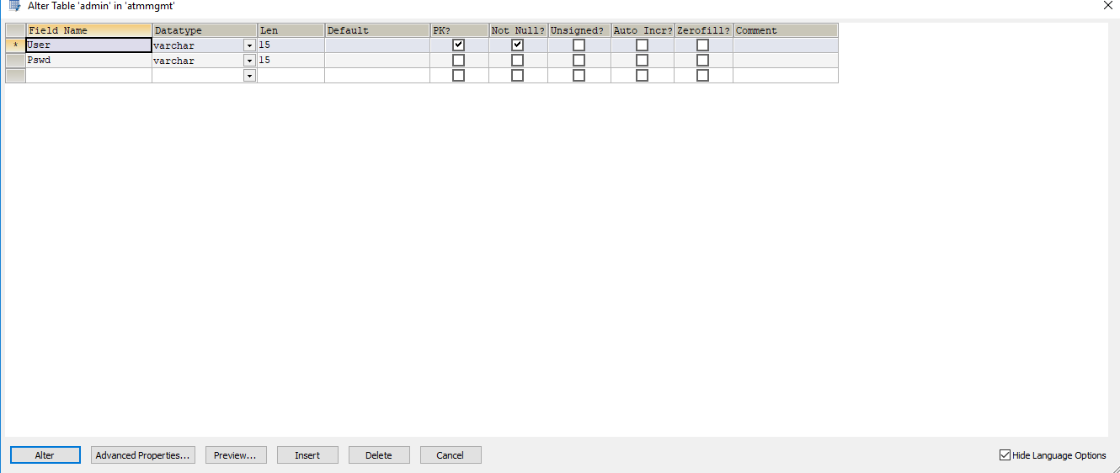

**Open Account Table:-**

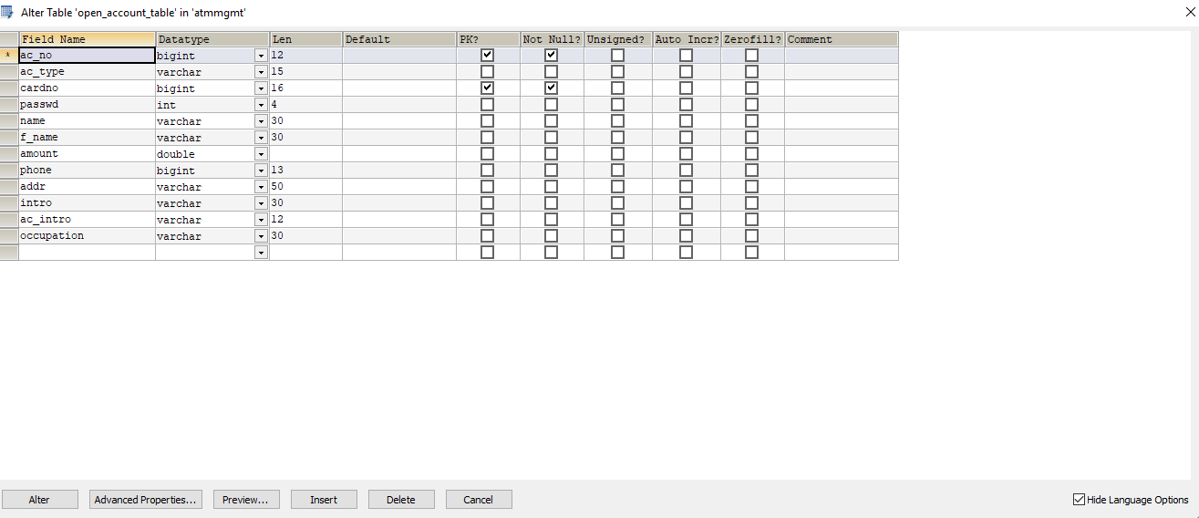

**transaction Table:-**

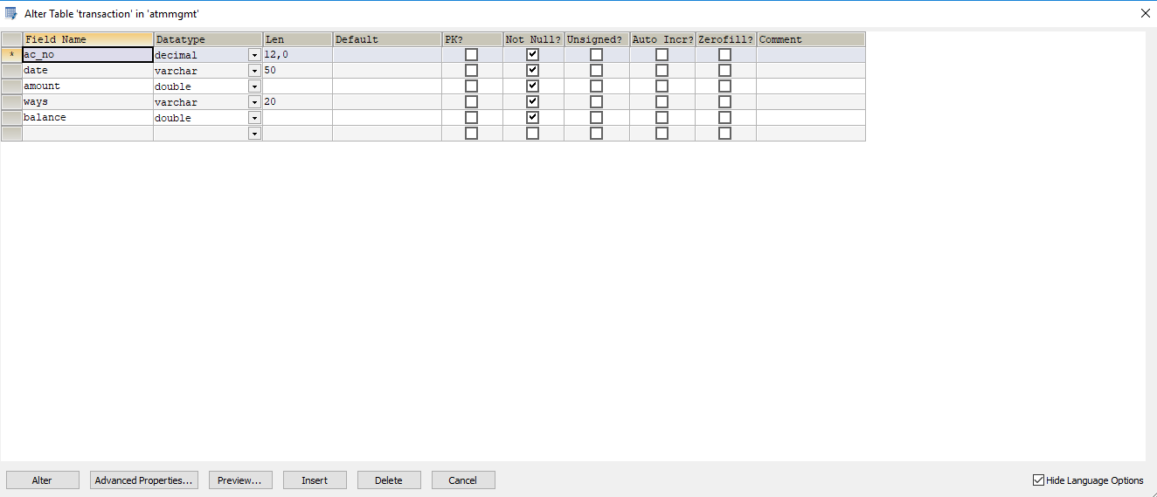

**Transaction Table:-**

|  |  |  |
| --- | --- | --- |
| FIELDS | DATATYPE | LENGTH |
| ac_no | decimal | 12,0 |
| date | varchar | 50 |
| amount | double |  |
| ways | varchar | 20 |
| balance | double |  |

**Admin Table:**

|  |  |  |
| --- | --- | --- |
| FIELDS | DATATYPE | LENGTH |
| User | varchar | 15 |
| Pswd | varchar | 15 |

**Open Account Table:-**

|  |  |  |
| --- | --- | --- |
| FIELD | DATATYPE | LENGTH |
| ac_no | bigint | 12 |
| ac_type | varchar | 15 |
| cardno | bigint | 16 |
| passwd | int | 4 |
| name | varchar | 30 |
| f_name | varchar | 30 |
| amount | double | 50 |
| phone | bigint | 13 |
| addr | varchar | 50 |
| intro | varchar | 30 |
| ac_intro | varchar | 12 |
| occupation | varchar | 30 |

**3.2 PLANNING AND SCHEDULING:-**

**PERT CHART**

A project plan needs to be created to ensure the timely completion of the project. As part of project analysis, we break the project down to a number of stages and use a Gantt chart and PERT chart to describe specific tasks and status. The Work Breakdown Structure of our proposed system “E-Commerce” is shown below:-

|  |  |  |  |  |  |  |  |  |  |
| --- | --- | --- | --- | --- | --- | --- | --- | --- | --- |
| ID |  | Task Name | Duration | Start | Finish |  | | |  |
| 1 |  | Project Initiation | 2 days | 1/7/18 | 3/7/18 |  | | |  |
| 2 |  | Draft Project Plan | 3 days | 6/7/18 | 7/7/18 |  | | |  |
| 3 |  | Analysis Phase | 8 days | 8/7/18 | 16/7/18 |  | | |  |
| 4 |  | Plan User Interviews | 2 days | 17/7/18 | 18/7/18 |  | | |  |
| 5 |  | Schedule users Interviews | 3 days | 19/7/18 | 22/7/18 |  | | |  |
| 6 |  | Conducting users Interviews | 2 days | 23/7/18 | 25/7/18 |  | | |  |
| 7 |  | System Design | 14 days | 26/7/18 | 9/8/18 |  | | |  |
| 8 |  | Modules Design | 10 days | 10/8/18 | 20/8/18 | |  |  | |
| 9 |  | Data Structure Design | 3 days | 21/8/18 | 24/8/18 | |  |  | |
| 10 |  | User Interface Design | 3 days | 25/8/18 | 28/8/18 | |  |  | |
| 11 |  | Coding Phase | 35 days | 29/8/18 | 4/10/18 | |  |  | |
| 12 |  | Testing Phase | 8 days | 5/10/18 | 13/10/18 | |  |  | |
| 13 |  | Integration Testing | 5 days | 14/10/18 | 19/10/18 | |  |  | |
| 14 |  | System Level Testing | 4 days | 20/10/18 | 24/10/18 | |  |  | |
| 15 |  | Implementation | 3 days | 25/10/18 | 28/10/18 | |  |  | |
| 16 |  | Post-Implementation | 2 days | 29/10/18 | 30/10/18 | |  |  | |

**3.3 REQUIREMENTS SPECIFICATION**

**3.3.1 Software Requirements:-**

* Java/JDK
* NetBeans
* MySql
* SQL YOG

**3.3.2 Hardware Requirements:-**

* Pentium IV Processor
* 512 MB RAM
* 40 GB HDD
* Color Monitor
* Keyboard
* Mouse

**3.4 PRELIMINRY PRODUCT DESCRPTION**

* **Detail information about system modules**

1. **Cash Withdrawal :-**

It mainly used for withdrawal of cash as per customer demand. For any authorized ATM card holder the ATM system requests for its ATM no & PIN no then customer to login in their accounts, then amounts are given to system and customer can withdraw amount.

1. **Cash Withdrawal :-**

It mainly used for withdrawal of cash as per customer demand. For any authorized ATM card holder the ATM system requests for its ATM no & PIN no then customer to login in their accounts, then amounts are given to system and customer can withdraw amount.

1. **Balance Enquiry :-**

It refers to enquiry of bank balance of an authorized ATM card holder account to check for the resulting balance after certain transactions.

1. **Mini Statement:-**

It refers to enquiry of last ten transaction of an authorized ATM card holder. It includes deposit & withdrawal amount of transaction & also contains respective transaction date and current available balance.

1. **PIN Change:-**

It refers to the Change of PIN no of an authorized ATM card holder. I require giving system old PIN no of the ATM card & then giving new PIN no & confirm the new PIN no.

1. **Cash Deposit:-**

It mainly used for deposit cash amount to their bank account as per customer demand. It is easy process of deposit amount to their bank accounts without filling deposit sleep.

**7. Transfer Money:-**

It is mainly used to Transfer Money from one Account to Another Account with the help of ATM system. It is also secure because when Transferring money PIN (Personal Identification Number) must required.

**8. Mobile Registration:-**

It is mainly used to Register your mobile number when mobile number is not registered before. And it is also in use when you have to change your current mobile number with new Mobile number i.e. Updating Mobile number to your account.

**9. Fast Cash Withdrawal:-**

This method is same as Cash Withdrawal but it reduces some time and some work for example, pressing buttons to demand money for transaction.

**3.5 COCEPTUAL MODEL**

Waterfall approach was first SDLC Model to be used widely in Software Engineering to ensure success of the project. In "The Waterfall" approach, the

whole process of software development is divided into separate phases. In this Waterfall model, typically, the outcome of one phase acts as the input for the next phase sequentially.

The following illustration is a representation of the different phases of the Waterfall Model.

* **Requirement Gathering and analysis** − All possible requirements of the system to be developed are captured in this phase and documented in a requirement specification document.
* **System Design** − The requirement specifications from first phase are studied in this phase and the system design is prepared. This system design helps in specifying hardware and system requirements and helps in defining the overall system architecture.
* **Implementation** − With inputs from the system design, the system is first developed in small programs called units, which are integrated in the next phase.

Each unit is developed and tested for its functionality, which is referred to as Unit Testing.

* **Integration and Testing** − All the units developed in the implementation phase are integrated into a system after testing of each unit. Post integration the entire system is tested for any faults and failures.
* **Deployment of system** − Once the functional and non-functional testing is done; the product is deployed in the customer environment or released into the market.
* **Maintenance:**− There are some issues which come up in the client environment. To fix those issues, patches are released. Also to enhance the product some better versions are released. Maintenance is done to deliver these changes in the customer environment.

All these phases are cascaded to each other in which progress is seen as flowing steadily downwards (like a waterfall) through the phases. The next phase is started only after the defined set of goals are achieved for previous phase and it is signed off, so the name "Waterfall Model". In this model, phases do not overlap.

Requirement Analysis

System Design

Implementation

Testing

Deployement

Maintainence

**WATERFALL MODEL**

**Waterfall Model – Application**

Every software developed is different and requires a suitable SDLC approach to be followed based on the internal and external factors. Some situations where the use of Waterfall model is most appropriate are –

* Requirements are very well documented, clear and fixed.
* Product definition is stable.
* Technology is understood and is not dynamic.
* There are no ambiguous requirements.
* Ample resources with required expertise are available to support the product.
* The project is short

**Waterfall Model – Advantages**

The advantages of waterfall development are that it allows for departmentalization and control. A schedule can be set with deadlines for each stage of development and a product can proceed through the development process model phases one by one.

Development moves from concept, through design, implementation, testing, installation, troubleshooting, and ends up at operation and maintenance. Each phase of development proceeds in strict order.

Some of the major advantages of the Waterfall Model are as follows −

* Simple and easy to understand and use
* Easy to manage due to the rigidity of the model. Each phase has specific deliverables and a review process.
* Phases are processed and completed one at a time.
* Works well for smaller projects where requirements are very well understood.
* Clearly defined stages.
* Well understood milestones.
* Easy to arrange tasks.
* Process and results are well documented.

**Waterfall Model – Disadvantages**

The disadvantage of waterfall development is that it does not allow much reflection or revision. Once an application is in the testing stage, it is very difficult to go back and change something that was not well-documented or thought upon in the concept stage.

The major disadvantages of the Waterfall Model are as follows −

* No working software is produced until late during the life cycle.
* High amounts of risk and uncertainty.
* Not a good model for complex and object-oriented projects.
* Poor model for long and ongoing projects.
* Not suitable for the projects where requirements are at a moderate to high risk of changing. So, risk and uncertainty is high with this process model.
* It is difficult to measure progress within stages.
* Cannot accommodate changing requirements.
* Adjusting scope during the life cycle can end a project.
* Integration is done as a "big-bang. at the very end, which doesn't allow identifying any technological or business bottleneck or challenges early.

**4.References**

Material referred for the development of this “**Automated Teller Machine (ATM)System**” is as follows.

**Bibliography:-**

Books referred during project development**:**

1. Complete Reference Java 8. By Mr. Herbert Schildt.
2. JAVA 2 Black Book By Mr. Steven Holzner.
3. Software Engineering By Mrs. Sharada patil.

**Website Reference:-**

1. [www.javaworld.com](http://www.javaworld.com)
2. [www.kashipara.com](http://www.kashipara.com)
3. [www.tutorialspoint.com](http://www.tutorialspoint.com)
4. [www.m.youtube.com](http://www.m.youtube.com)

PROJECT CODE

**CODING FOR SPLASH :**

public class ATM_Mgmt_System{

public static void main(String[] args)

{

Progress Splash=new Progress();

Splash.setVisible(true);

try{

for (int i = 0; i <= 100; i++)

{

Thread.sleep(25);

Splash.load.setText(Integer.toString(i)+"%");

Splash.loadbar.setValue(i);}

Thread.sleep(500);

Splash.setVisible(false);

}

catch (Exception e)

{

}

new Home().setVisible(true);

}}

**CODING FOR HOME :**

public class Home extends javax.swing.JFrame

{

public Home()

{

initComponents();

setLocation(200,75);

}

private void jLabel8MouseEntered(java.awt.event.MouseEvent evt)

{

jLabel10.setVisible(false);

jPanel2.setOpaque(true);

jPanel2.setBackground(Color.white);

jLabel8.setForeground(Color.black);

}

private void jPanel2MouseEntered(java.awt.event.MouseEvent evt)

{

jLabel10.setVisible(false);

jPanel2.setOpaque(true);

jPanel2.setBackground(Color.white);

jLabel8.setForeground(Color.black);

}

private void jPanel3MouseEntered(java.awt.event.MouseEvent evt)

{

jPanel3.setBackground(Color.white);

jLabel10.setVisible(false);

jPanel3.setOpaque(true);

jLabel5.setForeground(Color.black);

}

private void jPanel2MouseExited(java.awt.event.MouseEvent evt)

{

jLabel8.setForeground(Color.white);

jPanel2.setOpaque(false);

jLabel10.setVisible(true);

jPanel2.setBackground(new Color(240,240,240));

}

private void jPanel3MouseExited(java.awt.event.MouseEvent evt)

{

jLabel10.setVisible(true);

jPanel3.setBackground(new Color(240,240,240));jLabel5.setForeground(Color.white);

jPanel3.setOpaque(false);

}

private void jLabel5MouseEntered(java.awt.event.MouseEvent evt)

{

jPanel3.setBackground(Color.white);

jLabel10.setVisible(false);jPanel3.setOpaque(true);

jLabel5.setForeground(Color.black);

}

private void jLabel8MouseExited(java.awt.event.MouseEvent evt)

{

jLabel10.setVisible(true);

jLabel8.setForeground(Color.white);

jPanel2.setOpaque(false);

jPanel2.setBackground(new Color(240,240,240));

}

private void jLabel5MouseExited(java.awt.event.MouseEvent evt)

{

jLabel10.setVisible(true);

jPanel3.setBackground(new Color(240,240,240));jLabel5.setForeground(Color.white);

jPanel3.setOpaque(false);

}

private void jPanel2MouseClicked(java.awt.event.MouseEvent evt)

{

new Login().setVisible(true);

this.setVisible(false);

}

private void jLabel8MouseClicked(java.awt.event.MouseEvent evt)

{

new Login().setVisible(true);

this.setVisible(false);

}

private void jLabel5MouseClicked(java.awt.event.MouseEvent evt)

{

new Adminlogin().setVisible(true);

this.setVisible(false);}

**CODING FOR AADMIN LOGIN :**

public class Adminlogin extends javax.swing.JFrame

{

public Adminlogin()

{

initComponents();

setLocation(280,90);

jPanel2.setBackground(new Color(0,255,0,60));

jPanel3.setBackground(new Color(0,255,0,60));

jPanel4.setBackground(new Color(0,255,0,60));

jTextField1.setBackground(new Color(0,255,0,60));

jPasswordField1.setBackground(new Color(0,255,0,60));

}

private void jPanel4MouseEntered(java.awt.event.MouseEvent evt)

{

jPanel4.setBackground(new Color(0,0,0,200));

}

private void jPanel4MouseExited(java.awt.event.MouseEvent evt)

{

jPanel4.setBackground(new Color(0,255,0,60));}

**Coding for login on admin page :**

private void jLabel4MouseClicked(java.awt.event.MouseEvent evt)

{

try

{

String user=jTextField1.getText();

String pswd=jPasswordField1.getText();

DBConnection db=new DBConnection();

db.pstmt=db.con.prepareStatement("select * from admin where user=?");

db.pstmt.setString(1,user);

db.rst=db.pstmt.executeQuery();

if(db.rst.next())

{

String p1=db.rst.getString(2);

if(pswd.equals(p1))

{

new adminpanel().setVisible(true);

this.setVisible(false);

}

else

{

JOptionPane.showMessageDialog(this,"Incorrect Password");

JOptionPane.showMessageDialog(this,"Unauthorize Access");

new Home().setVisible(true);

}

}

else

{

JOptionPane.showMessageDialog(this,"Invalid user");

}

}

catch(Exception e)

{

}

}

private void jLabel4MouseEntered(java.awt.event.MouseEvent evt)

{

jPanel4.setBackground(new Color(0,0,0,200));

}

private void jLabel4MouseExited(java.awt.event.MouseEvent evt)

{

jPanel4.setBackground(new Color(0,255,0,60));

}

private void jTextField1MouseClicked(java.awt.event.MouseEvent evt)

{

jTextField1.setText("");

jTextField1.setOpaque(false);

}

private void jPasswordField1MouseClicked(java.awt.event.MouseEvent evt)

{

jPasswordField1.setText("");

}

private void jLabel6MouseClicked(java.awt.event.MouseEvent evt)

{

new Home().setVisible(true);

this.setVisible(false);

}

private void jLabel6MouseEntered(java.awt.event.MouseEvent evt)

{

jLabel6.setBorder(newjavax.swing.border.LineBorder(new java.awt.Color(255,255,255),1,true));

}

private void jLabel6MouseExited(java.awt.event.MouseEvent evt)

{

jLabel6.setBorder(null);

}

**CODING FOR ADMIN PANEL :**

public class adminpanel extends javax.swing.JFrame

{

public adminpanel()

{

initComponents();

setLocation(270,90);

jPanel4.setBackground(new Color(0,0,0,70));

}

private void jPanel6MouseEntered(java.awt.event.MouseEvent evt)

{

jPanel6.setBackground(new Color(0,0,0,70));

Font i=new Font("Century Gothic",21,26);

jLabel4.setFont(i);

}

private void jPanel6MouseExited(java.awt.event.MouseEvent evt)

{

jPanel6.setBackground(new Color(204,204,204,0));

Font i=new Font("Century Gothic",21,18);

jLabel4.setFont(i);

jLabel4.setForeground(Color.black);

}

private void jPanel7MouseEntered(java.awt.event.MouseEvent evt)

{

jPanel7.setBackground(new Color(0,0,0,70));

Font i=new Font("Century Gothic",21,26);

jLabel5.setFont(i);

jLabel5.setText("Modify Account");

}

private void jPanel7MouseExited(java.awt.event.MouseEvent evt)

{

jPanel7.setBackground(new Color(204,204,204,0));

Font i=new Font("Century Gothic",21,18);

jLabel5.setFont(i);

jLabel5.setText("Search,Update Account");

jLabel5.setForeground(Color.black);

}

private void jPanel8MouseEntered(java.awt.event.MouseEvent evt)

{

jPanel8.setBackground(new Color(0,0,0,70));

Font i=new Font("Century Gothic",21,26);

jLabel6.setFont(i);

}

private void jPanel8MouseExited(java.awt.event.MouseEvent evt)

{

jPanel8.setBackground(new Color(204,204,204,0));

Font i=new Font("Century Gothic",21,18);

jLabel6.setFont(i);

jLabel6.setForeground(Color.black);

}

private void jPanel9MouseEntered(java.awt.event.MouseEvent evt)

{

jPanel9.setBackground(new Color(0,0,0,70));

Font i=new Font("Century Gothic",21,26);

jLabel7.setFont(i);

}

private void jPanel9MouseExited(java.awt.event.MouseEvent evt)

{

jPanel9.setBackground(new Color(204,204,204,0));

Font i=new Font("Century Gothic",21,18);

jLabel7.setFont(i);

jLabel7.setForeground(Color.black);

}

private void jLabel8MouseEntered(java.awt.event.MouseEvent evt)

{

jPanel6.setBackground(new Color(0,0,0,70));

Font i=new Font("Century Gothic",21,26);

jLabel4.setFont(i);

}

private void jLabel8MouseExited(java.awt.event.MouseEvent evt)

{

jPanel6.setBackground(new Color(204,204,204,0));

Font i=new Font("Century Gothic",21,18);

jLabel4.setFont(i);

jLabel4.setForeground(Color.black);

}

private void jLabel9MouseEntered(java.awt.event.MouseEvent evt)

{

jPanel7.setBackground(new Color(0,0,0,70));

Font i=new Font("Century Gothic",21,26);

jLabel5.setFont(i);

jLabel5.setText("Modify Account");

}

private void jLabel9MouseExited(java.awt.event.MouseEvent evt)

{

jPanel7.setBackground(new Color(204,204,204,0));

Font i=new Font("Century Gothic",21,18);

jLabel5.setFont(i);

jLabel5.setText("Search,Update Account");

jLabel5.setForeground(Color.black);

}

private void jLabel10MouseEntered(java.awt.event.MouseEvent evt)

{

jPanel8.setBackground(new Color(0,0,0,70));

Font i=new Font("Century Gothic",21,26);

jLabel6.setFont(i);

}

private void jLabel10MouseExited(java.awt.event.MouseEvent evt)

{

jPanel8.setBackground(new Color(204,204,204,0));

Font i=new Font("Century Gothic",21,18);

jLabel6.setFont(i);

jLabel6.setForeground(Color.black);

}

private void jLabel11MouseEntered(java.awt.event.MouseEvent evt)

{

jLabel7.setFont(new Font("Century Gothic",21,26));// TODO add your handling code here:

}

private void jLabel11MouseExited(java.awt.event.MouseEvent evt)

{

Font i=new Font("Century Gothic",21,18);

jLabel7.setFont(i);

}

private void jLabel4MouseClicked(java.awt.event.MouseEvent evt)

{

new Openaccount().setVisible(true);

this.setVisible(false);

}

private void jLabel8MouseClicked(java.awt.event.MouseEvent evt)

{

new Openaccount().setVisible(true);

this.setVisible(false);

}

private void jPanel6MouseClicked(java.awt.event.MouseEvent evt)

{

new Openaccount().setVisible(true);

this.setVisible(false);

}

private void jLabel4MouseEntered(java.awt.event.MouseEvent evt)

{

jPanel6.setBackground(new Color(0,0,0,70));

Font i=new Font("Century Gothic",21,26);

jLabel4.setFont(i);

}

private void jLabel17MouseEntered(java.awt.event.MouseEvent evt)

{

jPanel10.setBorder(newjavax.swing.border.LineBorder

(new java.awt.Color(0,0,0),1,true));

}

private void jLabel17MouseExited(java.awt.event.MouseEvent evt)

{

jPanel10.setBorder(null);

}

private void jLabel17MouseClicked(java.awt.event.MouseEvent evt)

{

new Home().setVisible(true);

this.setVisible(false);

}

private void jLabel5MouseEntered(java.awt.event.MouseEvent evt)

{

jPanel7.setBackground(new Color(0,0,0,70));

Font i=new Font("Century Gothic",21,26);

jLabel5.setFont(i);

jLabel5.setText("Modify Account");

}

private void jLabel5MouseClicked(java.awt.event.MouseEvent evt)

{

new modaccount().setVisible(true);

this.setVisible(false);

}

private void jLabel9MouseClicked(java.awt.event.MouseEvent evt)

{

new modaccount().setVisible(true);

this.setVisible(false);

}

private void jLabel6MouseClicked(java.awt.event.MouseEvent evt)

{

new viewptrans().setVisible(true);

this.setVisible(false);

}

private void jLabel10MouseClicked(java.awt.event.MouseEvent evt)

{

new viewptrans().setVisible(true);

this.setVisible(false);

}

private void jLabel6MouseEntered(java.awt.event.MouseEvent evt)

{

jPanel8.setBackground(new Color(0,0,0,70));

Font i=new Font("Century Gothic",21,26);

jLabel6.setFont(i);

}

private void jLabel6MouseExited(java.awt.event.MouseEvent evt)

{

jPanel8.setBackground(new Color(204,204,204,0));

Font i=new Font("Century Gothic",21,18);

jLabel6.setFont(i);

jLabel6.setForeground(Color.black);

}

private void jLabel7MouseClicked(java.awt.event.MouseEvent evt)

{

new viewatrans().setVisible(true);

this.setVisible(false);

}

private void jLabel7MouseEntered(java.awt.event.MouseEvent evt)

{

jPanel8.setBackground(new Color(0,0,0,70));

jLabel7.setFont(new Font("Century Gothic",21,26));

}

private void jLabel11MouseClicked(java.awt.event.MouseEvent evt)

{

new viewatrans().setVisible(true);

this.setVisible(false);

}

**Coding for open account page :**

public Openaccount()

{

initComponents();

setLocation(200,70);

}

private void jLabel13MouseEntered(java.awt.event.MouseEvent evt)

{

jPanel5.setBorder(newjavax.swing.border.LineBorder(new java.awt.Color(0,0,0),1,true));

}

private void jLabel13MouseExited(java.awt.event.MouseEvent evt)

{

jPanel5.setBorder(null);

}

private void jLabel22MouseEntered(java.awt.event.MouseEvent evt)

{

jLabel22.setForeground(new Color(0,0,0));

}

private void jLabel22MouseExited(java.awt.event.MouseEvent evt)

{

jLabel22.setForeground(Color.white);}}

private void jLabel22MouseClicked(java.awt.event.MouseEvent evt)

{

new adminpanel().setVisible(true);

this.setVisible(false);

}

**Coding for submit :**

private void jLabel13MouseClicked(java.awt.event.MouseEvent evt)

{

try

{

String amt=jTextField11.getText();

String name=jTextField1.getText();

String fname=jTextField6.getText();

String phone=jTextField5.getText();

String address=jTextField4.getText();

String intro=jTextField7.getText();

String acintro=jTextField8.getText();

String occup=jTextField3.getText();

String ano=jTextField9.getText();

String crd=jTextField2.getText();

String pswd=jTextField10.getText();

String atype=jComboBox1.getSelectedItem().toString();

DBConnection db=new DBConnection();

db.pstmt=db.con.prepareStatement("insert into open_account_table values(?,?,?,?,?,?,?,?,?,?,?,?)");

db.pstmt.setString(1,ano);

db.pstmt.setString(2,atype);

db.pstmt.setString(3,crd);

db.pstmt.setString(4,pswd);

db.pstmt.setString(5,name);

db.pstmt.setString(6,fname);

db.pstmt.setString(7,amt);

db.pstmt.setString(8,phone);

db.pstmt.setString(9,address);

db.pstmt.setString(10,intro);

db.pstmt.setString(11,acintro);

db.pstmt.setString(12,occup);

int i=db.pstmt.executeUpdate();

if(i>0)

{

JOptionPane.showMessageDialog(this,"Account has been successfully created");

try

{String d="Deposit";

DBConnection db2=new DBConnection();

db2.pstmt=db2.con.prepareStatement("insert into transaction values(?,?,?,?,?)");

db2.pstmt.setString(1,ano);

db2.pstmt.setString(2,new Date().toString());

db2.pstmt.setString(3,amt);

db2.pstmt.setString(4,d);

db2.pstmt.setString(5,amt);

db2.pstmt.executeUpdate(); }

catch(Exception e)

{

}

new adminpanel().setVisible(true);

this.setVisible(false);

}

else {

JOptionPane.showMessageDialog(this,"Please Try Later");

}}

catch(Exception e)

{

}}

**CODING FOR MODIFY ACCOUNT**

public class modaccount extends javax.swing.JFrame

{

public modaccount()

{

initComponents();

setLocation(135,70);

}

private void jLabel14MouseEntered(java.awt.event.MouseEvent evt)

{

jLabel14.setBorder(newjavax.swing.border.LineBorder(new java.awt.Color(255,255,255),1,true));

jLabel14.setForeground(Color.white);

}

private void jLabel17MouseEntered(java.awt.event.MouseEvent evt)

{

jLabel17.setBorder(newjavax.swing.border.LineBorder(new java.awt.Color(255,255,255),1,true));

}

private void jLabel17MouseExited(java.awt.event.MouseEvent evt)

{

jLabel17.setBorder(null);

}

private void jLabel14MouseExited(java.awt.event.MouseEvent evt)

{

jLabel14.setBorder(null);

jLabel14.setForeground(new Color(204,204,204));

}

private void jLabel15MouseEntered(java.awt.event.MouseEvent evt)

{

jLabel15.setBorder(newjavax.swing.border.LineBorder(new java.awt.Color(255,255,255),1,true));

jLabel15.setForeground(Color.white);

}

private void jLabel15MouseExited(java.awt.event.MouseEvent evt)

{

jLabel15.setBorder(null);

jLabel15.setForeground(new Color(204,204,204));

}

**Coding for account no. :**

private void jLabel17MouseClicked(java.awt.event.MouseEvent evt)

{

try

{

String ano=jTextField1.getText();

DBConnection db=new DBConnection();

db.pstmt=db.con.prepareStatement("select * from open_account_table where ac_no=?");

db.pstmt.setString(1,ano);

db.rst=db.pstmt.executeQuery();

if(db.rst.next())

{

jTextField2.setText(db.rst.getString(2));

jTextField3.setText(db.rst.getString(3));

jTextField4.setText(db.rst.getString(4));

jTextField5.setText(db.rst.getString(10));

jTextField6.setText(db.rst.getString(11));

jTextField7.setText(db.rst.getString(9));

jTextField8.setText(db.rst.getString(5));

jTextField9.setText(db.rst.getString(6));

jTextField11.setText(db.rst.getString(8));

jTextField12.setText(db.rst.getString(12));

}

else

{

JOptionPane.showMessageDialog(this,"Invalid Account No.");

jTextField1.setText("");

jTextField2.setText("");

jTextField3.setText("");

jTextField4.setText("");

jTextField5.setText("");

jTextField6.setText("");

jTextField7.setText("");

jTextField8.setText("");

jTextField9.setText("");

jTextField11.setText("");

jTextField12.setText("");

}}

catch(Exception e)

{

e.printStackTrace();

}

}

**Coding for update :**

private void jLabel14MouseClicked(java.awt.event.MouseEvent evt)

{

try

{

String an=jTextField1.getText();

String atyp=jTextField2.getText();

String cd=jTextField3.getText();

String pd=jTextField4.getText();

String intr=jTextField5.getText();

String aintr=jTextField6.getText();

String ad=jTextField7.getText();

String nm=jTextField8.getText();

String fnm=jTextField9.getText();

String phn=jTextField11.getText();

String oc=jTextField12.getText();

DBConnection db=new DBConnection();

db.pstmt=db.con.prepareStatement("update open_account_table set ac_type=?,cardno=?,passwd=?,name=?,f_name=?,phone=?,addr=?,intro=?,ac_intro=?,occupation=? where ac_no=?");

db.pstmt.setString(1,atyp);

db.pstmt.setString(2,cd);

db.pstmt.setString(3,pd);

db.pstmt.setString(4,nm);

db.pstmt.setString(5,fnm);

db.pstmt.setString(6,phn);

db.pstmt.setString(7,ad);

db.pstmt.setString(8,intr);

db.pstmt.setString(9,aintr);

db.pstmt.setString(10,oc);

db.pstmt.setString(11,an);

int i=db.pstmt.executeUpdate();

if(i>0)

{

JOptionPane.showMessageDialog(this,"Account updated Successfully");

jTextField1.setText("");

jTextField2.setText("");

jTextField3.setText("");

jTextField4.setText("");

jTextField5.setText("");

jTextField6.setText("");

jTextField7.setText("");

jTextField8.setText("");

jTextField9.setText("");

jTextField11.setText("");

jTextField12.setText("");

}

else

JOptionPane.showMessageDialog(this,"Error in updating Account info");

}

catch(Exception e)

{

e.printStackTrace();

}

}

**Coding for Delete :**

private void jLabel15MouseClicked(java.awt.event.MouseEvent evt)

{

try

{

String ano=jTextField1.getText();

DBConnection db=new DBConnection();

db.pstmt=db.con.prepareStatement("delete from open_account_table where ac_no=?");

db.pstmt.setString(1,ano);

int i=db.pstmt.executeUpdate();

if(i>0)

{

JOptionPane.showMessageDialog(this,"Account Deleted Successfully");

jTextField1.setText("");

jTextField2.setText("");

jTextField3.setText("");

jTextField4.setText("");

jTextField5.setText("");

jTextField6.setText("");

jTextField7.setText("");

jTextField8.setText("");

jTextField9.setText("");

jTextField11.setText("");

jTextField12.setText("");

}

else

JOptionPane.showMessageDialog(this,"Error in Deleting Account");

}

catch(Exception e)

{

e.printStackTrace();

}

}

private void jLabel11MouseEntered(java.awt.event.MouseEvent evt)

{

jLabel11.setBorder(newjavax.swing.border.LineBorder(new java.awt.Color(255,255,255),1,true));

jLabel11.setForeground(Color.white);

}

private void jLabel11MouseExited(java.awt.event.MouseEvent evt)

{

jLabel11.setBorder(null);

jLabel11.setForeground(new Color(204,204,204));

}

private void jLabel11MouseClicked(java.awt.event.MouseEvent evt)

{

new adminpanel().setVisible(true);

this.setVisible(false);

}

**Coding for edit :**

private void jLabel18MouseClicked(java.awt.event.MouseEvent evt)

{

jTextField2.setEditable(true);

jLabel18.setVisible(false);

jTextField3.setEditable(true);

jTextField4.setEditable(true);

jTextField5.setEditable(true);

jTextField6.setEditable(true);

jTextField7.setEditable(true);

jTextField8.setEditable(true);

jTextField9.setEditable(true);

jTextField12.setEditable(true);

j

TextField11.setEditable(true);

}

private void jLabel18MouseEntered(java.awt.event.MouseEvent evt)

{

jLabel18.setBorder(new javax.swing.border.LineBorder((Color.white),1,true));

}

private void jLabel18MouseExited(java.awt.event.MouseEvent evt)

{

jLabel18.setBorder(null);

}

**CODING FOR VIEW TRANSACTIONS :**

public class viewptrans extends javax.swing.JFrame

{

public viewptrans()

{

initComponents();

tab1();

setLocation(200,80);

jLabel2.setBorder(newjavax.swing.border.LineBorder(new java.awt.Color(255,255,255),1,true));

}

void tab1()

{

try

{

Vector<String> header=new Vector<String>();

header.add("Account No");

header.add("Ac-Type");

header.add("Card No");

header.add("Name");

header.add("F-Name");

header.add("Phone");

header.add("Occupation");

Vector<Vector<String>> data=new Vector<Vector<String>>();

DBConnection db=new DBConnection();

db.pstmt=db.con.prepareStatement("select * from open_account_table");

db.rst=db.pstmt.executeQuery();

while(db.rst.next())

{

Vector<String> temp=new Vector<String>();

temp.add(db.rst.getString(1));

temp.add(db.rst.getString(2));

temp.add(db.rst.getString(3));

temp.add(db.rst.getString(5));

temp.add(db.rst.getString(6));

temp.add(db.rst.getString(8));

temp.add(db.rst.getString(12));

data.add(temp);

}

jTable1.setModel(new DefaultTableModel(data,header));

}

catch(Exception e)

{

e.printStackTrace();

}

}

void tab2()

{

String ac=jTextField1.getText();

try

{

DBConnection db1=new DBConnection();

db1.pstmt=db1.con.prepareStatement("select ac_no from open_account_table where ac_no=?");

db1.pstmt.setString(1,ac);

db1.rst=db1.pstmt.executeQuery();

if(db1.rst.next())

{

String acn=db1.rst.getString(1);

if(ac.equals(acn))

{

Vector<String> header=new Vector<String>();

header.add("Account No");

header.add("Date");

header.add("Amount");

header.add("Ways");

header.add("Balance");

Vector<Vector<String>> data=new Vector<Vector<String>>();

DBConnection db=new DBConnection();

db.pstmt=db.con.prepareStatement("select * from transaction where ac_no=?");

db.pstmt.setString(1,ac);

db.rst=db.pstmt.executeQuery();

while(db.rst.next())

{

Vector<String> temp=new Vector<String>();

temp.add(db.rst.getString(1));

temp.add(db.rst.getString(2));

temp.add(db.rst.getString(3));

temp.add(db.rst.getString(4));

temp.add(db.rst.getString(5));

data.add(temp);

}

jTable3.setModel(new DefaultTableModel(data,header));

}

else

{

JOptionPane.showMessageDialog(this,"Invalid Account No.");

new adminpanel().setVisible(true);

this.setVisible(false);

}}

else

{

JOptionPane.showMessageDialog(this,"Invalid Account No.");

new adminpanel().setVisible(true);

this.setVisible(false);

}

}

catch(Exception e)

{

e.printStackTrace();

}

}

**Coding for load:**

private void jLabel2MouseClicked(java.awt.event.MouseEvent evt)

{

tab2();

}

private void jLabel2MouseEntered(java.awt.event.MouseEvent evt)

{

jLabel2.setForeground(Color.black);

jLabel2.setBorder(newjavax.swing.border.LineBorder(new java.awt.Color(0,0,0),1,true));

}

private void jLabel2MouseExited(java.awt.event.MouseEvent evt)

{

jLabel2.setForeground(Color.white);

jLabel2.setBorder(null);

}

**Coding for back :**

private void jLabel3MouseClicked(java.awt.event.MouseEvent evt)

{

new adminpanel().setVisible(true);

this.setVisible(false);

}

private void jLabel3MouseEntered(java.awt.event.MouseEvent evt)

{

jLabel3.setBorder(newjavax.swing.border.LineBorder

(new java.awt.Color(0,0,0),1,true));

}

private void jLabel3MouseExited(java.awt.event.MouseEvent evt)

{

jLabel3.setBorder(null);

}

**CODING FOR VIEW ALL TRANSACTIONS :**

public class viewatrans extends javax.swing.JFrame

{

public viewatrans()

{

initComponents();

setLocation(200,80);

atrans();

}

void atrans()

{

try

{

Vector<String> header=new Vector<String>();

header.add("Account No");

header.add("Date");

header.add("Amount");

header.add("Ways");

header.add("Balance");

Vector<Vector<String>> data=new Vector<Vector<String>>();

DBConnection db=new DBConnection();

db.pstmt=db.con.prepareStatement("select * from transaction");

db.rst=db.pstmt.executeQuery();

while(db.rst.next())

{

Vector<String> temp=new Vector<String>();

temp.add(db.rst.getString(1));

temp.add(db.rst.getString(2));

temp.add(db.rst.getString(3));

temp.add(db.rst.getString(4));

temp.add(db.rst.getString(5));

data.add(temp);

}

jTable1.setModel(new DefaultTableModel(data,header));

}

catch(Exception e)

{

e.printStackTrace();

}

}

**Coding for back :**

private void jLabel2MouseClicked(java.awt.event.MouseEvent evt)

{

new adminpanel().setVisible(true);

this.setVisible(false);

}

private void jLabel2MouseEntered(java.awt.event.MouseEvent evt)

{

jLabel2.setBorder(newjavax.swing.border.LineBorder(new java.awt.Color(0,0,0),1,true));

}

private void jLabel2MouseExited(java.awt.event.MouseEvent evt)

{

jLabel2.setBorder(null);

}

**CODING FOR LOGIN :**

public class Login extends javax.swing.JFrame

{

public Login()

{

initComponents();

setLocation(200,75);

setTitle("Card Identifier");

}

private void jLabel7MouseEntered(java.awt.event.MouseEvent evt)

{

jTextField1.setBorder(newjavax.swing.border.LineBorder

(new java.awt.Color(0,0,0), 1, true));

}

private void jLabel7MouseExited(java.awt.event.MouseEvent evt)

{

jTextField1.setBorder(null);

jTextField1.setOpaque(false);

}

private void jLabel8MouseEntered(java.awt.event.MouseEvent evt)

{

jLabel8.setForeground(Color.white);

jLabel4.setVisible(false);

jLabel8.setForeground(Color.white);

jPanel5.setBorder(newjavax.swing.border.LineBorder

(new Color(255,255,255),1,true));

}

private void jPanel5MouseEntered(java.awt.event.MouseEvent evt)

{

jLabel4.setVisible(false);

jPanel5.setOpaque(true);

jPanel5.setBackground(new Color(153,0,255));

jLabel8.setForeground(Color.black);

}

private void jPanel5MouseExited(java.awt.event.MouseEvent evt)

{

jPanel5.setOpaque(false);

jLabel4.setVisible(true);

jLabel8.setForeground(Color.white);

}

private void jLabel8MouseExited(java.awt.event.MouseEvent evt)

{

jPanel5.setBorder(null);

jLabel4.setVisible(true);

jLabel8.setForeground(Color.white);

}

private void jTextField1MouseClicked(java.awt.event.MouseEvent evt)

{

jTextField1.setText("");

jTextField1.setBackground(Color.white);

}

**Coding for CONFIRM :**

private void jLabel8MouseClicked(java.awt.event.MouseEvent evt)

{

try

{

String card=jTextField1.getText();

DBConnection db=new DBConnection();

db.pstmt=db.con.prepareStatement("select * from open_account_table where cardno=?");

db.pstmt.setString(1,card);

db.rst=db.pstmt.executeQuery();

if(db.rst.next())

{

String name=db.rst.getString(5);

String card1=db.rst.getString(3);

String acno=db.rst.getString(1);

if(card.equals(card1))

{

new Pin(name,acno,4).setVisible(true);

this.setVisible(false);

}}

else

{

jTextField1.setBackground(Color.red);

jTextField1.setText("INCORRECT CARD NO....!!!!"); } }

catch(Exception e)

{

e.printStackTrace(); }

**CODING FOR MENU PAGE :**

public class Menu extends javax.swing.JFrame

{

public Menu()

{

initComponents();

}

String acno;

public Menu(String ac)

{

initComponents();

setLocation(200,75);

setTitle(acno);

jLabel1.setVisible(false);

jLabel4.setVisible(false);

jLabel8.setVisible(false);

jLabel9.setVisible(false);

jLabel13.setVisible(false);

jLabel11.setVisible(false);

jLabel15.setVisible(false);

jLabel17.setVisible(false);

acno=ac;

}

private void jLabel5MouseEntered(java.awt.event.MouseEvent evt)

{

jLabel5.setVisible(false);

jLabel4.setVisible(true);

}

private void jLabel5MouseExited(java.awt.event.MouseEvent evt)

{

jLabel5.setVisible(true);

jLabel4.setVisible(false);

}

private void jPanel2MouseEntered(java.awt.event.MouseEvent evt)

{

jLabel5.setVisible(false);

jLabel4.setVisible(true);

jPanel2.setOpaque(true);

jPanel2.setBackground(new Color(0,204,204)); }

private void jPanel2MouseExited(java.awt.event.MouseEvent evt)

{

jLabel5.setVisible(true);

jLabel4.setVisible(false);

jPanel2.setOpaque(false);

jPanel2.setBackground(new Color(240,240,240));

}

private void jPanel3MouseEntered(java.awt.event.MouseEvent evt)

{

jLabel6.setVisible(false);

jLabel1.setVisible(true);

jPanel3.setOpaque(true);

jPanel3.setBackground(new Color(0,204,204));

}

private void jPanel3MouseExited(java.awt.event.MouseEvent evt)

{

jLabel6.setVisible(true);

jLabel1.setVisible(false);

jPanel3.setOpaque(false);

jPanel3.setBackground(new Color(240,240,240));

}

private void jPanel4MouseEntered(java.awt.event.MouseEvent evt)

{

jLabel8.setVisible(true);

jLabel7.setVisible(false);

jPanel4.setOpaque(true);

jPanel4.setBackground(new Color(0,204,204));

}

private void jPanel4MouseExited(java.awt.event.MouseEvent evt)

{

jLabel8.setVisible(false);

jLabel7.setVisible(true);

jPanel4.setOpaque(false);

jPanel4.setBackground(new Color(240,240,240));

}

private void jPanel5MouseEntered(java.awt.event.MouseEvent evt)

{

jLabel9.setVisible(true);

jLabel10.setVisible(false);

jPanel5.setOpaque(true);

jPanel5.setBackground(new Color(0,204,204));

}

private void jPanel5MouseExited(java.awt.event.MouseEvent evt)

{

jLabel9.setVisible(false);

jLabel10.setVisible(true);

jPanel5.setOpaque(false);

jPanel5.setBackground(new Color(240,240,240));

}

private void jPanel6MouseEntered(java.awt.event.MouseEvent evt)

{

jLabel11.setVisible(true);

jLabel12.setVisible(false);

jPanel6.setOpaque(true);

jPanel6.setBackground(new Color(0,204,204));

}

private void jPanel6MouseExited(java.awt.event.MouseEvent evt)

{

jLabel11.setVisible(false);

jLabel12.setVisible(true);

jPanel6.setOpaque(false);

jPanel6.setBackground(new Color(240,240,240));

}

private void jPanel7MouseEntered(java.awt.event.MouseEvent evt)

{

jLabel13.setVisible(true);

jLabel14.setVisible(false);

jPanel7.setOpaque(true);

jPanel7.setBackground(new Color(0,204,204));

}

private void jPanel7MouseExited(java.awt.event.MouseEvent evt)

{

jLabel13.setVisible(false);

jLabel14.setVisible(true);

jPanel7.setOpaque(false);

jPanel7.setBackground(new Color(240,240,240));

}

private void jPanel8MouseEntered(java.awt.event.MouseEvent evt)

{

jLabel15.setVisible(true);

jLabel16.setVisible(false);

jPanel8.setOpaque(true);

jPanel8.setBackground(new Color(0,204,204));

}

private void jPanel8MouseExited(java.awt.event.MouseEvent evt)

{

jLabel15.setVisible(false);

jLabel16.setVisible(true);

jPanel8.setOpaque(false);

jPanel8.setBackground(new Color(240,240,240));

}

private void jPanel9MouseEntered(java.awt.event.MouseEvent evt)

{

jLabel17.setVisible(true);

jLabel18.setVisible(false);

jPanel9.setOpaque(true);

jPanel9.setBackground(new Color(0,204,204));

}

private void jPanel9MouseExited(java.awt.event.MouseEvent evt)

{

jLabel17.setVisible(false);

jLabel18.setVisible(true);

jPanel9.setOpaque(false);

jPanel9.setBackground(new Color(240,240,240));

}

private void jPanel2MouseClicked(java.awt.event.MouseEvent evt)

{

new BalInq(acno,1).setVisible(true);

this.setVisible(false);

}

private void jPanel4MouseClicked(java.awt.event.MouseEvent evt)

{

new ChangePin(acno).setVisible(true);

this.setVisible(false);

}

private void jPanel5MouseClicked(java.awt.event.MouseEvent evt)

{

new Deposit(acno).setVisible(true);

this.setVisible(false);

}

private void jPanel3MouseClicked(java.awt.event.MouseEvent evt)

{

new BalInq(acno,0).setVisible(true);

this.setVisible(false);

}

private void jPanel7MouseClicked(java.awt.event.MouseEvent evt)

{

try

{DBConnection db=new DBConnection();

db.pstmt=db.con.prepareStatement("select name from open_account_table where ac_no=?");

db.pstmt.setString(1,acno);

db.rst=db.pstmt.executeQuery();

if(db.rst.next())

{

String names=db.rst.getString(1);

new Pin(names,acno,1).setVisible(true);

this.setVisible(false);

}

}

catch(Exception e)

{

e.printStackTrace();

}

}

private void jPanel9MouseClicked(java.awt.event.MouseEvent evt)

{

new MobileReg(acno).setVisible(true);

this.setVisible(false);

}

private void jPanel8MouseClicked(java.awt.event.MouseEvent evt)

{

new FastCash(acno).setVisible(true);

this.setVisible(false);

}

private void jPanel6MouseClicked(java.awt.event.MouseEvent evt)

{

new MiniStmt(acno).setVisible(true);

this.setVisible(false);

setTitle("What can we do for you today..");

}

private void jLabel3MouseEntered(java.awt.event.MouseEvent evt)

{

jLabel3.setBorder(new javax.swing.border.LineBorder((Color.white),1,true));

}

private void jLabel3MouseExited(java.awt.event.MouseEvent evt)

{

jLabel3.setBorder(null);

}

private void jLabel3MouseClicked(java.awt.event.MouseEvent evt)

{

new Last(acno).setVisible(true);

this.setVisible(false);

}

**CODING FOR BALANCE INQUIRY :**

public class BalInq extends javax.swing.JFrame

{

public BalInq()

{

initComponents();

}

String acno;int a;

public BalInq(String ac,int i)

{

initComponents();

acno=ac;

a=i;

setLocation(200,75);

}

private void jLabel3MouseEntered(java.awt.event.MouseEvent evt)

{

jLabel8.setVisible(false);

jLabel7.setVisible(false);

jLabel9.setVisible(true);

jLabel3.setForeground(Color.black);

jLabel6.setVisible(false);

jLabel5.setVisible(false);

jLabel4.setVisible(false);

jLabel2.setForeground(Color.black);

jLabel1.setForeground(Color.black);

}

private void jLabel3MouseExited(java.awt.event.MouseEvent evt)

{

jLabel8.setVisible(false);

jLabel7.setVisible(true);

jLabel9.setVisible(false);

jLabel6.setVisible(true);

jLabel5.setVisible(true);

jLabel4.setVisible(true);

jLabel3.setForeground(Color.white);

jLabel2.setForeground(Color.white);

jLabel1.setForeground(Color.white);

}

private void jLabel2MouseEntered(java.awt.event.MouseEvent evt)

{

jLabel8.setVisible(true);

jLabel7.setVisible(false);

jLabel9.setVisible(false);

jLabel3.setForeground(Color.black);

jLabel6.setVisible(false);

jLabel5.setVisible(false);

jLabel4.setVisible(false);

jLabel2.setForeground(Color.black);

jLabel1.setForeground(Color.black);

}

private void jLabel2MouseExited(java.awt.event.MouseEvent evt)

{

jLabel8.setVisible(false);

jLabel7.setVisible(true);

jLabel9.setVisible(false);

jLabel6.setVisible(true);

jLabel5.setVisible(true);

jLabel4.setVisible(true);

jLabel3.setForeground(Color.white);

jLabel2.setForeground(Color.white);

jLabel1.setForeground(Color.white);

}

private void jLabel4MouseEntered(java.awt.event.MouseEvent evt)

{

jLabel4.setForeground(Color.red);

jLabel1.setForeground(Color.red);

}

private void jLabel4MouseExited(java.awt.event.MouseEvent evt)

{

jLabel4.setForeground(Color.white);

jLabel1.setForeground(Color.white);

}

**Coding for saving account:**

private void jLabel2MouseClicked(java.awt.event.MouseEvent evt)

{

try

{

String save="Saving";

DBConnection db=new DBConnection();

db.pstmt=db.con.prepareStatement("select ac_type,name from open_account_table where ac_no=?");

db.pstmt.setString(1,acno);

db.rst=db.pstmt.executeQuery();

if(db.rst.next())

{

String type=db.rst.getString(1);

String name=db.rst.getString(2);

if(type.equals(save))

{

if(a==1)

{

new BalInq1(acno).setVisible(true);

this.setVisible(false);}

else

{

new Withdrawal(acno).setVisible(true);

this.setVisible(false);

}

}

else

{

try

{

new Home().setVisible(true);

this.setVisible(false);

ImageIcon icon1=new ImageIcon("denied.png");

JOptionPane.showMessageDialog(null,null,null,JOptionPane.WARNING_MESSAGE,icon1) ;

}

catch(Exception e)

{

}}

}}

catch(Exception e)

{

e.printStackTrace();

}

}

**Coding for current account :**

private void jLabel3MouseClicked(java.awt.event.MouseEvent evt)

{

try

{

String save="Current";

DBConnection db=new DBConnection();

db.pstmt=db.con.prepareStatement("select ac_type,name from open_account_table where ac_no=?");

db.pstmt.setString(1,acno);

db.rst=db.pstmt.executeQuery();

if(db.rst.next())

{

String type=db.rst.getString(1);

String name=db.rst.getString(2);

if(type.equals(save))

{

if(a==1)

{new BalInq1(acno).setVisible(true);

this.setVisible(false);

}

else

{

new Withdrawal(acno).setVisible(true);

this.setVisible(false);

}

}

else

{

try

{

new Home().setVisible(true);

this.setVisible(false);

ImageIcon icon1=new ImageIcon("denied.png");

JOptionPane.showMessageDialog(null,null,null,JOptionPane.WARNING_MESSAGE,icon1) ;

}

catch(Exception e)

{

}

}

}}

catch(Exception e)

{

e.printStackTrace();

}

}

**CODING FOR BALANCE INQUIRY 1 PAGE :**

public class BalInq1 extends javax.swing.JFrame

{

String acno;

public BalInq1(String ac)

{

initComponents();

setLocation(200,75);

acno=ac;

bal();

jLabel9.setVisible(false);

jLabel10.setVisible(false);

jLabel11.setVisible(false);

}

public BalInq1()

{

initComponents();

}

void bal()

{

try

{

DBConnection db=new DBConnection();

db.pstmt=db.con.prepareStatement("select name,amount from open_account_table where ac_no=?");

db.pstmt.setString(1, acno);

db.rst=db.pstmt.executeQuery();

if(db.rst.next())

{

jLabel8.setText(db.rst.getString(1));

jLabel6.setText(db.rst.getString(2));

}

}

catch (Exception ex)

{

}

}

**CODING FOR CHANGE PASSWORD :**

public class ChangePin extends javax.swing.JFrame

{

public ChangePin()

{

initComponents();

setLocation(250,75);

}

String acno;

public ChangePin(String ac)

{

initComponents();

acno=ac;

setLocation(230,75);

}

**coding for submit :**

private void jLabel7MouseEntered(java.awt.event.MouseEvent evt)

{

jPanel2.setBorder(newjavax.swing.border.LineBorder(new java.awt.Color(0,0,0),1,true));

}

private void jLabel7MouseExited(java.awt.event.MouseEvent evt)

{

jPanel2.setBorder(null);

}

private void jLabel7MouseClicked(java.awt.event.MouseEvent evt)

{

try

{

String curp=jPasswordField1.getText();

String newp=jPasswordField2.getText();

String conp=jPasswordField3.getText();

DBConnection db=new DBConnection();

db.pstmt=db.con.prepareStatement("select passwd from open_account_table where ac_no=?");

db.pstmt.setString(1,acno);

db.rst=db.pstmt.executeQuery();

if(db.rst.next())

{

String dbcurp=db.rst.getString(1);

if(curp.equals(dbcurp))

{

if(newp.equals(conp))

{

db.pstmt=db.con.prepareStatement("update open_account_table set passwd=? where ac_no=?");

db.pstmt.setString(1,conp);

db.pstmt.setString(2,acno);

int i=db.pstmt.executeUpdate();

if(i>0)

{

ImageIcon icon1=new ImageIcon("PSWDCHNGSCC.png");

JOptionPane.showMessageDialog(null,null,null,JOptionPane.WARNING_MESSAGE,icon1) ;

jPasswordField1.setText("");

jPasswordField2.setText("");

jPasswordField3.setText("");

new Last(acno).setVisible(true);

this.setVisible(false);

}

else

try

{

ImageIcon icon2=new ImageIcon("PSWDCHNGNOT.png");

JOptionPane.showMessageDialog(null,null,null,JOptionPane.WARNING_MESSAGE,icon2) ;

}

catch(Exception e)

{

}

}

else

try

{

ImageIcon icon2=new ImageIcon("NPCPDNM.png");

JOptionPane.showMessageDialog(null,null,null,JOptionPane.WARNING_MESSAGE,icon2) ;

}

catch(Exception e)

{

}

}

else

{

try

{

ImageIcon icon2=new ImageIcon("INCPSWD.png");

JOptionPane.showMessageDialog(null,null,null,JOptionPane.WARNING_MESSAGE,icon2) ;

}

catch(Exception e)

{

}

}

}

else

{

JOptionPane.showMessageDialog(this,"ERROR...!!! please try again Later..");

this.setVisible(false);

new Last(acno).setVisible(true);

}

}

catch(Exception e)

{

e.printStackTrace();

}

}

**CODING FOR MINI STATEMENT PAGE :**

public class MiniStmt extends javax.swing.JFrame

{

public MiniStmt()

{

initComponents();

}

String acno;

public MiniStmt(String ac)

{

initComponents();

acno=ac;

setLocation(200,75);

MINI();

}

void MINI()

{

try

{

Vector<String> header=new Vector<String>();

header.add("Account No.");

header.add("Date");

header.add("Amount");

header.add("Transaction Type");

header.add("Balance");

Vector<Vector<String>> data=new Vector<Vector<String>>();

DBConnection db=new DBConnection();

db.pstmt=db.con.prepareStatement("select * from Transaction where ac_no=?");

db.pstmt.setString(1,acno);

db.rst=db.pstmt.executeQuery();

while(db.rst.next())

{

Vector<String> temp=new Vector<String>();

temp.add(db.rst.getString(1));

temp.add(db.rst.getString(2));

temp.add(db.rst.getString(3));

temp.add(db.rst.getString(4));

temp.add(db.rst.getString(5));

data.add(temp);

}

jTable1.setModel(new DefaultTableModel(data,header));

}

catch(Exception e)

{

e.printStackTrace();

}

}

private void jLabel4MouseEntered(java.awt.event.MouseEvent evt)

{

jLabel4.setForeground(Color.black);

}

private void jLabel4MouseExited(java.awt.event.MouseEvent evt)

{

jLabel4.setForeground(Color.white);

}

private void jLabel3MouseEntered(java.awt.event.MouseEvent evt)

{

jLabel3.setForeground(Color.black);

}

private void jLabel3MouseExited(java.awt.event.MouseEvent evt)

{

jLabel3.setForeground(Color.white);

}

private void jLabel4MouseClicked(java.awt.event.MouseEvent evt)

{

new Menu(acno).setVisible(true);

this.setVisible(false);

}

private void jLabel3MouseClicked(java.awt.event.MouseEvent evt)

{

try

{

boolean complete = jTable1.print();

if (complete)

{

JOptionPane.showMessageDialog(this,"Statement is Printed");

}

else

{

JOptionPane.showMessageDialog(this,"Cancelled ***");

}

}

catch (Exception pe)

{

}

}

**CODING FOR FAST CASH :**

public class FastCash extends javax.swing.JFrame

{

String acno;

public FastCash(String ac)

{

initComponents();

setLocation(200,80);

acno=ac;

}

public FastCash()

{

initComponents();

}

private void jLabel4MouseEntered(java.awt.event.MouseEvent evt)

{

jLabel4.setForeground(Color.white);

jLabel16.setForeground(new Color(0,153,153));

jPanel4.setBorder(newjavax.swing.border.LineBorder

(new java.awt.Color(255,255,255),1,true);

}

private void jLabel4MouseExited(java.awt.event.MouseEvent evt)

{

jLabel4.setForeground(Color.black);

jPanel4.setBorder(null);

jLabel16.setForeground(Color.black);

}

private void jLabel5MouseEntered(java.awt.event.MouseEvent evt)

{

jLabel5.setForeground(Color.white);

jLabel17.setForeground(new Color(0,153,153));

jPanel5.setBorder(newjavax.swing.border.LineBorder

(new java.awt.Color(255,255,255),1,true));

}

private void jLabel5MouseExited(java.awt.event.MouseEvent evt)

{

jLabel5.setForeground(Color.black);

jLabel17.setForeground(Color.black);

jPanel5.setBorder(null);

}

private void jLabel6MouseEntered(java.awt.event.MouseEvent evt)

{

jLabel6.setForeground(Color.white);

jLabel18.setForeground(new Color(0,153,153));

jPanel6.setBorder(newjavax.swing.border.LineBorder

(new java.awt.Color(255,255,255),1,true));

}

private void jLabel6MouseExited(java.awt.event.MouseEvent evt)

{

jLabel6.setForeground(Color.black);

jPanel6.setBorder(null);jLabel18.setForeground(Color.black);

}

private void jLabel7MouseEntered(java.awt.event.MouseEvent evt)

{

jLabel7.setForeground(Color.white);

jLabel19.setForeground(new Color(0,153,153));

jPanel7.setBorder(newjavax.swing.border.LineBorder

(new java.awt.Color(255,255,255),1,true));

}

private void jLabel8MouseEntered(java.awt.event.MouseEvent evt)

{

jLabel8.setForeground(Color.white);

jLabel12.setForeground(new Color(0,153,153));

jPanel8.setBorder(newjavax.swing.border.LineBorder(new java.awt.Color(255,255,255),1,true));

}

private void jLabel9MouseEntered(java.awt.event.MouseEvent evt)

{

jLabel9.setForeground(Color.white);

jLabel13.setForeground(new Color(0,153,153));

jPanel9.setBorder(newjavax.swing.border.LineBorder(new java.awt.Color(255,255,255),1,true));

}

private void jLabel10MouseEntered(java.awt.event.MouseEvent evt)

{

jLabel14.setForeground(new Color(0,153,153));jLabel10.setForeground(Color.white);

jPanel10.setBorder(newjavax.swing.border.LineBorder(new java.awt.Color(255,255,255),1,true));

}

private void jLabel11MouseEntered(java.awt.event.MouseEvent evt)

{

jLabel11.setForeground(Color.white);

jLabel15.setForeground(new Color(0,153,153));

jPanel11.setBorder(newjavax.swing.border.LineBorder(new java.awt.Color(255,255,255),1,true));

}

private void jLabel7MouseExited(java.awt.event.MouseEvent evt)

{

jLabel19.setForeground(Color.black);jLabel7.setForeground(Color.black);

jPanel7.setBorder(null);

}

private void jLabel8MouseExited(java.awt.event.MouseEvent evt)

{

jLabel8.setForeground(Color.black);

jLabel12.setForeground(Color.black);

jPanel8.setBorder(null);

}

private void jLabel9MouseExited(java.awt.event.MouseEvent evt)

{

jLabel9.setForeground(Color.black);

jPanel9.setBorder(null);

jLabel13.setForeground(Color.black);

}

private void jLabel10MouseExited(java.awt.event.MouseEvent evt)

{

jLabel10.setForeground(Color.black);

jPanel10.setBorder(null);

jLabel14.setForeground(Color.black);

}

private void jLabel11MouseExited(java.awt.event.MouseEvent evt)

{

jLabel11.setForeground(Color.black);

jPanel11.setBorder(null);

jLabel15.setForeground(Color.black);

}

private void jLabel3MouseEntered(java.awt.event.MouseEvent evt)

{

jLabel3.setForeground(Color.white);

jPanel3.setBorder(newjavax.swing.border.LineBorder(new java.awt.Color(255,255,255),1,true));

}

private void jLabel3MouseExited(java.awt.event.MouseEvent evt)

{

jLabel3.setForeground(Color.black);

jPanel3.setBorder(null);

}

**Coding for 2000:**

private void jLabel4MouseClicked(java.awt.event.MouseEvent evt)

{

try

{

int amt=2000;

String d="Withdraw";

DBConnection db=new DBConnection();

db.pstmt=db.con.prepareStatement("select amount from open_account_table where ac_no=?");

db.pstmt.setString(1, acno);

db.rst=db.pstmt.executeQuery();

if(db.rst.next())

{

int amt1=Integer.parseInt(db.rst.getString(1));

if(amt>amt1)

{

JOptionPane.showMessageDialog(this,"Your account does not have Enough Money");

new Last(acno).setVisible(true);

this.setVisible(false);

JOptionPane.showMessageDialog(this,"Transaction Unsuccessful");

}

else

{

String amt2=String.valueOf(amt1-amt);

String amt3=String.valueOf(amt);

db.pstmt=db.con.prepareStatement("update open_account_table set amount=? where ac_no=?");

db.pstmt.setString(1,amt2);

db.pstmt.setString(2,acno);

int i=db.pstmt.executeUpdate();

if(i>0)

{

DBConnection db1=new DBConnection();

db1.pstmt=db1.con.prepareStatement("insert into transaction values(?,?,?,?,?)");

db1.pstmt.setString(1,acno);

db1.pstmt.setString(2,new Date().toString());

db1.pstmt.setString(3,amt3);

db1.pstmt.setString(4,d);

db1.pstmt.setString(5,amt2);

db1.pstmt.executeUpdate();

new Last(acno).setVisible(true);

this.setVisible(false);

new successful(acno).setVisible(true);

}}}}

catch(Exception e)

{

e.printStackTrace();

}

}

**Coding for 5000:**

private void jLabel5MouseClicked(java.awt.event.MouseEvent evt)

{

try

{

int amt=5000;

String d="Withdraw";

DBConnection db=new DBConnection();

db.pstmt=db.con.prepareStatement("select amount from open_account_table where ac_no=?");

db.pstmt.setString(1, acno);

db.rst=db.pstmt.executeQuery();

if(db.rst.next())

{

int amt1=Integer.parseInt(db.rst.getString(1));

if(amt>amt1)

{

JOptionPane.showMessageDialog(this,"Your account does not have Enough Money");

new Last(acno).setVisible(true);

this.setVisible(false);

JOptionPane.showMessageDialog(this,"Transaction Unsuccessful");

}

else

{

String amt2=String.valueOf(amt1-amt);

String amt3=String.valueOf(amt);

db.pstmt=db.con.prepareStatement("update open_account_table set amount=? where ac_no=?");

db.pstmt.setString(1,amt2);

db.pstmt.setString(2,acno);

int i=db.pstmt.executeUpdate();

if(i>0)

{

DBConnection db1=new DBConnection();

db1.pstmt=db1.con.prepareStatement("insert into transaction values(?,?,?,?,?)");

db1.pstmt.setString(1,acno);

db1.pstmt.setString(2,new Date().toString());

db1.pstmt.setString(3,amt3);

db1.pstmt.setString(4,d);

db1.pstmt.setString(5,amt2);

db1.pstmt.executeUpdate();

new Last(acno).setVisible(true);

this.setVisible(false);

new successful(acno).setVisible(true);

}}}}

catch(Exception e)

{

e.printStackTrace();

}

}

**Coding for 10,000 :**

private void jLabel6MouseClicked(java.awt.event.MouseEvent evt)

{

try

{

int amt=10000;

String d="Withdraw";

DBConnection db=new DBConnection();

db.pstmt=db.con.prepareStatement("select amount from open_account_table where ac_no=?");

db.pstmt.setString(1, acno);

db.rst=db.pstmt.executeQuery();

if(db.rst.next())

{

int amt1=Integer.parseInt(db.rst.getString(1));

if(amt>amt1)

{

JOptionPane.showMessageDialog(this,"Your account does not have Enough Money");

new Last(acno).setVisible(true);

this.setVisible(false);

JOptionPane.showMessageDialog(this,"Transaction Unsuccessful");

}

else

{

String amt2=String.valueOf(amt1-amt);

String amt3=String.valueOf(amt);

db.pstmt=db.con.prepareStatement("update open_account_table set amount=? where ac_no=?");

db.pstmt.setString(1,amt2);

db.pstmt.setString(2,acno);

int i=db.pstmt.executeUpdate();

if(i>0)

{

DBConnection db1=new DBConnection();

db1.pstmt=db1.con.prepareStatement("insert into transaction values(?,?,?,?,?)");

db1.pstmt.setString(1,acno);

db1.pstmt.setString(2,new Date().toString());

db1.pstmt.setString(3,amt3);

db1.pstmt.setString(4,d);

db1.pstmt.setString(5,amt2);

db1.pstmt.executeUpdate();

new Last(acno).setVisible(true);

this.setVisible(false);

new successful(acno).setVisible(true);

}}}}

catch(Exception e)

{

e.printStackTrace();

}

}

private void jLabel8MouseClicked(java.awt.event.MouseEvent evt)

{

try

{

int amt=100;

String d="Withdraw";

DBConnection db=new DBConnection();

db.pstmt=db.con.prepareStatement("select amount from open_account_table where ac_no=?");

db.pstmt.setString(1, acno);

db.rst=db.pstmt.executeQuery();

if(db.rst.next())

{

int amt1=Integer.parseInt(db.rst.getString(1));

if(amt>amt1)

{

JOptionPane.showMessageDialog(this,"Your account does not have Enough Money");

new Last(acno).setVisible(true);

this.setVisible(false);

JOptionPane.showMessageDialog(this,"Transaction Unsuccessful");

}

else

{

String amt2=String.valueOf(amt1-amt);

String amt3=String.valueOf(amt);

db.pstmt=db.con.prepareStatement("update open_account_table set amount=? where ac_no=?");

db.pstmt.setString(1,amt2);

db.pstmt.setString(2,acno);

int i=db.pstmt.executeUpdate();

if(i>0)

{

DBConnection db1=new DBConnection();

db1.pstmt=db1.con.prepareStatement("insert into transaction values(?,?,?,?,?)");

db1.pstmt.setString(1,acno);

db1.pstmt.setString(2,new Date().toString());

db1.pstmt.setString(3,amt3);

db1.pstmt.setString(4,d);

db1.pstmt.setString(5,amt2);

db1.pstmt.executeUpdate();

new Last(acno).setVisible(true);

this.setVisible(false);

new successful(acno).setVisible(true);

}}}}

catch(Exception e)

{

e.printStackTrace();

}

}

private void jLabel9MouseClicked(java.awt.event.MouseEvent evt)

{

try

{

int amt=200;

String d="Withdraw";

DBConnection db=new DBConnection();

db.pstmt=db.con.prepareStatement("select amount from open_account_table where ac_no=?");

db.pstmt.setString(1, acno);

db.rst=db.pstmt.executeQuery();

if(db.rst.next())

{

int amt1=Integer.parseInt(db.rst.getString(1));

if(amt>amt1)

{

JOptionPane.showMessageDialog(this,"Your account does not have Enough Money");

new Last(acno).setVisible(true);

this.setVisible(false);

JOptionPane.showMessageDialog(this,"Transaction Unsuccessful");

}

else

{

String amt2=String.valueOf(amt1-amt);

String amt3=String.valueOf(amt);

db.pstmt=db.con.prepareStatement("update open_account_table set amount=? where ac_no=?");

db.pstmt.setString(1,amt2);

db.pstmt.setString(2,acno);

int i=db.pstmt.executeUpdate();

if(i>0)

{

DBConnection db1=new DBConnection();

db1.pstmt=db1.con.prepareStatement("insert into transaction values(?,?,?,?,?)");

db1.pstmt.setString(1,acno);

db1.pstmt.setString(2,new Date().toString());

db1.pstmt.setString(3,amt3);

db1.pstmt.setString(4,d);

db1.pstmt.setString(5,amt2);

db1.pstmt.executeUpdate();

new Last(acno).setVisible(true);

this.setVisible(false);

new successful(acno).setVisible(true);

}}}}

catch(Exception e)

{

e.printStackTrace();

}

}

private void jLabel10MouseClicked(java.awt.event.MouseEvent evt)

{

try

{

int amt=500;

String d="Withdraw";

DBConnection db=new DBConnection();

db.pstmt=db.con.prepareStatement("select amount from open_account_table where ac_no=?");

db.pstmt.setString(1, acno);

db.rst=db.pstmt.executeQuery();

if(db.rst.next())

{

int amt1=Integer.parseInt(db.rst.getString(1));

if(amt>amt1)

{

JOptionPane.showMessageDialog(this,"Your account does not have Enough Money");

new Last(acno).setVisible(true);

this.setVisible(false);

JOptionPane.showMessageDialog(this,"Transaction Unsuccessful");

}

else

{

String amt2=String.valueOf(amt1-amt);

String amt3=String.valueOf(amt);

db.pstmt=db.con.prepareStatement("update open_account_table set amount=? where ac_no=?");

db.pstmt.setString(1,amt2);

db.pstmt.setString(2,acno);

int i=db.pstmt.executeUpdate();

if(i>0)

{

DBConnection db1=new DBConnection();

db1.pstmt=db1.con.prepareStatement("insert into transaction values(?,?,?,?,?)");

db1.pstmt.setString(1,acno);

db1.pstmt.setString(2,new Date().toString());

db1.pstmt.setString(3,amt3);

db1.pstmt.setString(4,d);

db1.pstmt.setString(5,amt2);

db1.pstmt.executeUpdate();

new Last(acno).setVisible(true);

this.setVisible(false);

new successful(acno).setVisible(true);

}}

}}

catch(Exception e)

{

e.printStackTrace();

}

}

private void jLabel11MouseClicked(java.awt.event.MouseEvent evt)

{

try

{

int amt=1000;

String d="Withdraw";

DBConnection db=new DBConnection();

db.pstmt=db.con.prepareStatement("select amount from open_account_table where ac_no=?");

db.pstmt.setString(1, acno);

db.rst=db.pstmt.executeQuery();

if(db.rst.next())

{

int amt1=Integer.parseInt(db.rst.getString(1));

if(amt>amt1)

{

JOptionPane.showMessageDialog(this,"Your account does not have Enough Money");

new Last(acno).setVisible(true);

this.setVisible(false);

JOptionPane.showMessageDialog(this,"Transaction Unsuccessful");

}

else

{

String amt2=String.valueOf(amt1-amt);

String amt3=String.valueOf(amt);

db.pstmt=db.con.prepareStatement("update open_account_table set amount=? where ac_no=?");

db.pstmt.setString(1,amt2);

db.pstmt.setString(2,acno);

int i=db.pstmt.executeUpdate();

if(i>0)

{

DBConnection db1=new DBConnection();

db1.pstmt=db1.con.prepareStatement("insert into transaction values(?,?,?,?,?)");

db1.pstmt.setString(1,acno);

db1.pstmt.setString(2,new Date().toString());

db1.pstmt.setString(3,amt3);

db1.pstmt.setString(4,d);

db1.pstmt.setString(5,amt2);

db1.pstmt.executeUpdate();

new Last(acno).setVisible(true);

this.setVisible(false);

new successful(acno).setVisible(true);

}

}

}

}

catch(Exception e)

{

e.printStackTrace();

}

}

**CODING FOR WITHDRWAL :**

public class Withdrawal extends javax.swing.JFrame

{

public Withdrawal()

{

initComponents();

jPanel9.setVisible(false);

jLabel10.setVisible(false);

setLocation(200,75);

}

String acno;

public Withdrawal(String ac)

{

initComponents();

acno=ac;

jPanel9.setVisible(false);

jLabel10.setVisible(false);

setLocation(200,75);

}

**Coding for correct;**

private void jLabel11MouseClicked(java.awt.event.MouseEvent evt)

{

try

{

String amt2="0";

int amt=Integer.parseInt(jTextField1.getText());

String d="Withdraw";

if(amt%100==0)

{

if(amt<=10000)

{

DBConnection db=new DBConnection();

db.pstmt=db.con.prepareStatement("select amount from open_account_table where ac_no=?");

db.pstmt.setString(1, acno);

db.rst=db.pstmt.executeQuery();

if(db.rst.next())

{

int amt1=Integer.parseInt(db.rst.getString(1));

if(amt>amt1)

{

ImageIcon icon2=new ImageIcon("YDNH.png");

JOptionPane.showMessageDialog(null,null,null,JOptionPane.WARNING_MESSAGE,icon2) ;

new Last(acno).setVisible(true);

this.setVisible(false);

ImageIcon icon1=new ImageIcon("TA.png");

JOptionPane.showMessageDialog(null,null,null,JOptionPane.WARNING_MESSAGE,icon1) ;

}

else

{

amt2=String.valueOf(amt1-amt);

String amt3=String.valueOf(amt);

db.pstmt=db.con.prepareStatement("update open_account_table set amount=? where ac_no=?");

db.pstmt.setString(1,amt2);

db.pstmt.setString(2,acno);

int i=db.pstmt.executeUpdate();

if(i>0)

{

DBConnection db1=new DBConnection();

db1.pstmt=db1.con.prepareStatement("insert into transaction values(?,?,?,?,?)");

db1.pstmt.setString(1,acno);

db1.pstmt.setString(2,new Date().toString());

db1.pstmt.setString(3,amt3);

db1.pstmt.setString(4,d);

db1.pstmt.setString(5,amt2);

db1.pstmt.executeUpdate();

this.setVisible(false);

new Last(acno).setVisible(true);

new successful(acno).setVisible(true);

}

}

}

}

else

{

JOptionPane.showMessageDialog(this, "Amount must be less than 10000");

jTextField1.setText("");

}

}

else

{

jLabel7.setForeground(Color.red);

jLabel6.setForeground(Color.red);

}

}

catch(Exception e)

{

e.printStackTrace();

}

}

**CODING FOR DEPOSIT PAGE :**

public class Deposit extends javax.swing.JFrame

{

String acno;

public Deposit(String ac)

{

initComponents();

jPanel9.setVisible(false);

jLabel10.setVisible(false);

setLocation(200,75);

acno=ac;

}

public Deposit()

{

initComponents();

jPanel9.setVisible(false);

jLabel10.setVisible(false);

setLocation(200,75);

}

private void jLabel19MouseClicked(java.awt.event.MouseEvent evt)

{

String EnterNumber=jTextField1.getText()+"1";

jTextField1.setText(EnterNumber);

}

private void jLabel19MouseEntered(java.awt.event.MouseEvent evt)

{

jLabel19.setForeground(new Color(102,102,102));

}

private void jLabel19MouseExited(java.awt.event.MouseEvent evt)

{

jLabel19.setForeground(Color.black);

}

private void jLabel32MouseClicked(java.awt.event.MouseEvent evt)

{

String EnterNumber=jTextField1.getText()+"2";

jTextField1.setText(EnterNumber);

}

private void jLabel32MouseEntered(java.awt.event.MouseEvent evt)

{

jLabel32.setForeground(new Color(102,102,102));

}

private void jLabel32MouseExited(java.awt.event.MouseEvent evt)

{

jLabel32.setForeground(Color.black);

}

private void jLabel33MouseClicked(java.awt.event.MouseEvent evt)

{

String EnterNumber=jTextField1.getText()+"3";

jTextField1.setText(EnterNumber);

}

private void jLabel33MouseEntered(java.awt.event.MouseEvent evt)

{

jLabel33.setForeground(new Color(102,102,102));

}

private void jLabel33MouseExited(java.awt.event.MouseEvent evt)

{

jLabel33.setForeground(Color.black);

}

private void jLabel34MouseClicked(java.awt.event.MouseEvent evt)

{

String EnterNumber=jTextField1.getText()+"4";

jTextField1.setText(EnterNumber);

}

private void jLabel34MouseEntered(java.awt.event.MouseEvent evt)

{

jLabel34.setForeground(new Color(102,102,102));

}

private void jLabel34MouseExited(java.awt.event.MouseEvent evt)

{

jLabel34.setForeground(Color.black);

}

private void jLabel35MouseClicked(java.awt.event.MouseEvent evt)

{

String EnterNumber=jTextField1.getText()+"5";

jTextField1.setText(EnterNumber);

}

private void jLabel35MouseEntered(java.awt.event.MouseEvent evt)

{

jLabel35.setForeground(new Color(102,102,102));

}

private void jLabel35MouseExited(java.awt.event.MouseEvent evt)

{

jLabel35.setForeground(Color.black);

}

private void jLabel36MouseClicked(java.awt.event.MouseEvent evt)

{

String EnterNumber=jTextField1.getText()+"6";

jTextField1.setText(EnterNumber);

}

private void jLabel36MouseEntered(java.awt.event.MouseEvent evt)

{

jLabel36.setForeground(new Color(102,102,102));

}

private void jLabel36MouseExited(java.awt.event.MouseEvent evt)

{

jLabel36.setForeground(Color.black);

}

private void jLabel37MouseClicked(java.awt.event.MouseEvent evt)

{

String EnterNumber=jTextField1.getText()+"7";

jTextField1.setText(EnterNumber);

}

private void jLabel37MouseEntered(java.awt.event.MouseEvent evt)

{

jLabel37.setForeground(new Color(102,102,102));

}

private void jLabel37MouseExited(java.awt.event.MouseEvent evt)

{

jLabel37.setForeground(Color.black);

}

private void jLabel38MouseClicked(java.awt.event.MouseEvent evt)

{

String EnterNumber=jTextField1.getText()+"8";

jTextField1.setText(EnterNumber);

}

private void jLabel38MouseEntered(java.awt.event.MouseEvent evt)

{

jLabel38.setForeground(new Color(102,102,102));

}

private void jLabel38MouseExited(java.awt.event.MouseEvent evt)

{

jLabel38.setForeground(Color.black);

}

private void jLabel39MouseClicked(java.awt.event.MouseEvent evt)

{

String EnterNumber=jTextField1.getText()+"9";

jTextField1.setText(EnterNumber);

}

private void jLabel39MouseEntered(java.awt.event.MouseEvent evt)

{

jLabel39.setForeground(new Color(102,102,102));

}

private void jLabel39MouseExited(java.awt.event.MouseEvent evt)

{

jLabel39.setForeground(Color.black);

}

private void jLabel40MouseClicked(java.awt.event.MouseEvent evt)

{

String EnterNumber=jTextField1.getText()+"0";

jTextField1.setText(EnterNumber);

}

private void jLabel40MouseEntered(java.awt.event.MouseEvent evt)

{

jLabel40.setForeground(new Color(102,102,102));

}

private void jLabel40MouseExited(java.awt.event.MouseEvent evt)

{

jLabel40.setForeground(Color.black);

}

private void jLabel7MouseEntered(java.awt.event.MouseEvent evt)

{

jLabel7.setForeground(Color.white);

jLabel8.setForeground(Color.white);

jLabel8.setText(">");// TODO add your handling code here:

}

private void jLabel7MouseExited(java.awt.event.MouseEvent evt)

{

jLabel7.setForeground(Color.white);

jLabel8.setForeground(Color.white);

jLabel8.setText("<");

}

private void jLabel7MouseClicked(java.awt.event.MouseEvent evt)

{

jLabel7.setForeground(Color.white);

jLabel8.setForeground(Color.white);

jLabel8.setText(">");

jPanel9.setVisible(true);

jLabel8.setVisible(false);

jLabel7.setVisible(false);

jLabel10.setVisible(true);

}

private void jLabel10MouseClicked(java.awt.event.MouseEvent evt)

{

jPanel9.setVisible(false);

jLabel7.setVisible(true);

jLabel8.setVisible(true);

jLabel10.setVisible(false);

}

private void jLabel10MouseEntered(java.awt.event.MouseEvent evt)

{

jLabel10.setForeground(Color.gray);

}

private void jLabel10MouseExited(java.awt.event.MouseEvent evt)

{

jLabel10.setForeground(Color.white);

}

private void jLabel9MouseEntered(java.awt.event.MouseEvent evt)

{

jPanel2.setBorder(newjavax.swing.border.LineBorder(new java.awt.Color(255,255,255),1,true));

}

private void jLabel9MouseExited(java.awt.event.MouseEvent evt)

{

jPanel2.setBorder(null);

}

private void jTextField1MouseClicked(java.awt.event.MouseEvent evt)

{

jTextField1.setText("");

}

**Coding for SUBMIT :**

private void jLabel9MouseClicked(java.awt.event.MouseEvent evt)

{

try

{

int amt=Integer.parseInt(jTextField1.getText());

String d="Deposit";

if(amt%100==0)

{if(amt<=25000)

{

DBConnection db=new DBConnection();

db.pstmt=db.con.prepareStatement("select amount from open_account_table where ac_no=?");

db.pstmt.setString(1, acno);

db.rst=db.pstmt.executeQuery();

if(db.rst.next())

{

int amt1=Integer.parseInt(db.rst.getString(1));

String amt2=String.valueOf(amt1+amt);

String amt3=String.valueOf(amt);

db.pstmt=db.con.prepareStatement("update open_account_table set amount=? where ac_no=?");

db.pstmt.setString(1,amt2);

db.pstmt.setString(2,acno);

int i=db.pstmt.executeUpdate();

if(i>0)

{

DBConnection db1=new DBConnection();

db1.pstmt=db1.con.prepareStatement("insert into transaction values(?,?,?,?,?)");

db1.pstmt.setString(1,acno);

db1.pstmt.setString(2,new Date().toString());

db1.pstmt.setString(3,amt3);

db1.pstmt.setString(4,d);

db1.pstmt.setString(5,amt2);

db1.pstmt.executeUpdate();

new Last(acno).setVisible(true);

this.setVisible(false);

new successful(acno).setVisible(true);

}

}

}

else

{

JOptionPane.showMessageDialog(this,"Amount must be deposited less than or equal to 25000");

}

}

else

{

jLabel5.setForeground(Color.red);

jLabel6.setForeground(Color.red);

}

}

catch(Exception e)

{

e.printStackTrace();

}

}

**CODING FOR TRANSFER PAGE :**

public class Transfer extends javax.swing.JFrame

{

public Transfer()

{

initComponents();

}

String acno;

public Transfer(String ac)

{

initComponents();

acno=ac;

}

private void jLabel12MouseEntered(java.awt.event.MouseEvent evt)

{

jLabel12.setForeground(Color.black);

}

private void jLabel12MouseExited(java.awt.event.MouseEvent evt)

{

jLabel12.setForeground(new Color(0,153,153));

}

private void jTextField1MouseClicked(java.awt.event.MouseEvent evt)

{

jTextField1.setText("");

jTextField1.setForeground(new Color(0,153,153));}

private void jTextField2MouseClicked(java.awt.event.MouseEvent evt)

{

jTextField2.setText("");

jTextField2.setForeground(new Color(0,153,153));

}

**Coding for next :**

private void jLabel12MouseClicked(java.awt.event.MouseEvent evt)

{

try

{

String d="Transfer";

String ac1=jTextField1.getText();

String ac2=jTextField2.getText();

String am=jTextField3.getText();

int am1=Integer.parseInt(am);int amt7=0;

if(am1%100==0)

{

DBConnection db=new DBConnection();

db.pstmt=db.con.prepareStatement("select ac_no,amount from open_account_table where ac_no=?");

db.pstmt.setString(1,ac1);

db.rst=db.pstmt.executeQuery();

if(db.rst.next())

{

String ac3=db.rst.getString(1);

if(ac3.equals(ac1))

{

if(ac1.equals(ac2))

{

int amt=Integer.parseInt(db.rst.getString(2));

String amt1=String.valueOf(amt+am1);

DBConnection db6=new DBConnection();

db6.pstmt=db6.con.prepareStatement("select amount from open_account_table where ac_no=?");

db6.pstmt.setString(1,acno);

db6.rst=db6.pstmt.executeQuery();

if(db6.rst.next())

{

amt7=Integer.parseInt(db6.rst.getString(1));

if(am1>amt7)

{

try

{

ImageIcon icon2=new ImageIcon("NEBTS.png");

JOptionPane.showMessageDialog(null,null,null,JOptionPane.WARNING_MESSAGE,icon2) ;

}catch(Exception e)

{

}

new Last(acno).setVisible(true);

this.setVisible(false);

}else

{

DBConnection db1=new DBConnection();

db1.pstmt=db1.con.prepareStatement("update open_account_table set amount=? where ac_no=?");

db1.pstmt.setString(1,amt1);

db1.pstmt.setString(2,ac3);

int i=db1.pstmt.executeUpdate();

if(i>0)

{

DBConnection db2=new DBConnection();

db2.pstmt=db2.con.prepareStatement("insert into transaction values(?,?,?,?,?)");

db2.pstmt.setString(1,ac3);

db2.pstmt.setString(2,new Date().toString());

db2.pstmt.setString(3,am);

db2.pstmt.setString(4,d);

db2.pstmt.setString(5,amt1);

int j=db2.pstmt.executeUpdate();

if(j>0)

{

DBConnection db4=new DBConnection();

db4.pstmt=db4.con.prepareStatement("select name,amount from open_account_table where ac_no=?");

db4.pstmt.setString(1,acno);

db4.rst=db4.pstmt.executeQuery();

if(db4.rst.next())

{

String names=db4.rst.getString(1);

int amt5=Integer.parseInt(db4.rst.getString(2));

String amt6=String.valueOf(amt5-am1);

String d1="Send";

DBConnection db3=new DBConnection();

db3.pstmt=db3.con.prepareStatement("insert into transaction values(?,?,?,?,?)");

db3.pstmt.setString(1,acno);

db3.pstmt.setString(2,new Date().toString());

db3.pstmt.setString(3,am);

db3.pstmt.setString(4,d1);

db3.pstmt.setString(5,amt6);

int k=db3.pstmt.executeUpdate();

if(k>0)

{

DBConnection db5=new DBConnection();

db5.pstmt=db5.con.prepareStatement("update open_account_table set amount=? where ac_no=?");

db5.pstmt.setString(1, amt6);

db5.pstmt.setString(2, acno);

db5.pstmt.executeUpdate();

}

new Last(acno).setVisible(true);

this.setVisible(false);

new successful(acno).setVisible(true);

}}}}

}

}

else

{

try

{

ImageIcon icon2=new ImageIcon("MCA.png");

JOptionPane.showMessageDialog(null,null,null,JOptionPane.WARNING_MESSAGE,icon2) ;

}

catch(Exception e)

{

}

}

}

else

{

try

{

ImageIcon icon2=new ImageIcon("INA.png");

JOptionPane.showMessageDialog(null,null,null,JOptionPane.WARNING_MESSAGE,icon2) ;

}

catch(Exception e)

{

}

}}

else

{

try

{

ImageIcon icon2=new ImageIcon("INA.png");

JOptionPane.showMessageDialog(null,null,null,JOptionPane.WARNING_MESSAGE,icon2) ;

}

catch(Exception e)

{

}

}

}

else

{

jLabel9.setForeground(Color.red);

jLabel10.setForeground(Color.red);

}

}

catch(Exception e)

{

e.printStackTrace();

}

}

private void jTextField3MouseClicked(java.awt.event.MouseEvent evt)

{

jTextField3.setText("");

jTextField3.setForeground(new Color(0,153,153));

}

**CODING FOR MOBILE REGISTRATION :**

public class MobileReg extends javax.swing.JFrame

{

public MobileReg()

{

initComponents();

setLocation(225,85);

jLabel9.setVisible(false);

jPanel4.setVisible(false);

jTextField2.setVisible(false);

jPanel6.setVisible(false);

jSeparator3.setVisible(false);

}

String acno;

public MobileReg(String ac)

{

initComponents();

setLocation(225,85);

acno=ac;

jLabel9.setVisible(false);

jPanel4.setVisible(false);

jTextField2.setVisible(false);

jPanel6.setVisible(false);

jSeparator3.setVisible(false);

}

**coding for NEXT :**

private void jLabel10MouseClicked(java.awt.event.MouseEvent evt)

{

try

{

String num=jTextField1.getText();

DBConnection db1=new DBConnection();

db1.pstmt=db1.con.prepareStatement("select phone from open_account_table where phone=?");

db1.pstmt.setString(1,num);

db1.rst=db1.pstmt.executeQuery();

if(db1.rst.next())

{

String nn=db1.rst.getString(1);

if(num.equals(nn))

{

try

{

ImageIcon icon2=new ImageIcon("ALRREG.png");

JOptionPane.showMessageDialog(null,null,null,JOptionPane.WARNING_MESSAGE,icon2) ;

}

catch(Exception e)

{

}

new Last(acno).setVisible(true);

this.setVisible(false);

}}

else

{

int i=num.length();

if(i<10)

{

try

{

ImageIcon icon2=new ImageIcon("IPN.png");

JOptionPane.showMessageDialog(null,null,null,JOptionPane.WARNING_MESSAGE,icon2) ;

}catch(Exception e)

{

}

}

else

{

jTextField1.setVisible(false);

jPanel3.setVisible(false);

jSeparator2.setVisible(false);

jLabel10.setVisible(false);

jLabel9.setVisible(true);

jPanel4.setVisible(true);

jTextField2.setVisible(true);

jPanel6.setVisible(true);

jSeparator3.setVisible(true);

}}}

catch(Exception e)

{

e.printStackTrace();

}

}

private void jTextField1MouseClicked(java.awt.event.MouseEvent evt)

{

jTextField1.setText("");

jTextField1.setForeground(new Color(0,153,153));

}

**Coding for REGISTER :**

private void jLabel11MouseClicked(java.awt.event.MouseEvent evt)

{

try

{

String num1=jTextField1.getText();

String num2=jTextField2.getText();

if(num1.equals(num2))

{

DBConnection db=new DBConnection();

db.pstmt=db.con.prepareStatement("update open_account_table set phone=? where ac_no=?");

db.pstmt.setString(1,num2);

db.pstmt.setString(2,acno);

int j=db.pstmt.executeUpdate();

if(j>0)

{

JOptionPane.showMessageDialog(this,"Your Mobile no. is Successfully Registered");

new Last(acno).setVisible(true);

this.setVisible(false);

}

}

else

{

JOptionPane.showMessageDialog(this,"Mismatch in both Phone Numbers");

new MobileReg(acno).setVisible(true);

this.setVisible(false);

}

}

catch(Exception e)

{

e.printStackTrace();

}

}

TESTING

**TESTING**

**System Testing: -**

Black box testing method was used for system testing. The black box testing usually demonstrates that software functions are operational; that the input is properly accepted and the output is correctly produced; and that integrity of external information (databases) is maintained.

**Why testing is done-**

Testing is the process of running a system with the intention of finding errors.

Testing enhances the integrity of a system by detecting deviations in design and errors in the system.

Testing aims at detecting error-prone areas. This helps in the prevention of errors in a system.

Testing also add value to the product by confirming to the user requirements.

**Causes of Errors**

The most common causes of errors in a software system are:

* **Communication gap between the developer and the business decisionmaker:** A communication gap between the developer and the business decision maker is normally due to subtle differences between them. The differences can be classified into five broad areas: Thought process, Background and Experience, Interest, Priorities, Language.
* **Time provided to a developer to complete the project:** A common source of errors in projects comes from time constraints in delivering a product. To keep to the schedule, features can be cut. To keep the features, the schedule can be slipped. Failing to adjust
* the feature set or schedule when problems are discovered can lead to rushed work and flawed systems.
* **Over Commitment by the developer:** High enthusiasm can lead to over commitment by the developer. In these situations, developers are usually unable to adhere to deadlines or quality due to lack of resources or required skills on

the team.

* **Insufficient testing and quality control:** Insufficient testing is also a major source of breakdown of e-commerce systems during operations, as testing must be done during all phases of development.
* **Inadequate requirements gathering:**  A short time to market results in developers starting work on the Web site development without truly understanding the business and technical requirements. Also, developers may create client-side scripts using language that may not work on some client browsers.
* **Keeping pace with the fast changing Technology:** New technologies are constantly introduced. There may not be adequate time to develop expertise in the new technologies. This is a problem for two reasons. First, the technology may not be properly implemented. Second, the technology may not integrate well with the existing environment.

**Testing Principles**To discover as yet undiscovered errors.

All tests should be traceable to customer’s requirement.

Tests should be planned long before the testing actually begins.

* Testing should begin “in the small” & progress towards “testing in the large”.
* Exhaustive Testing is not possible.
* To be most effective training should be conducted by an Independent Third Party

**Testing Objectives**

* Testing is a process of executing a program with the intent of finding errors.
* A good test case is one that has a high probability of finding an as yet undiscovered error.
* A successful test is one that uncovers an as yet undiscovered error.

**Kinds of Testing:-**

**Black Box Testing- Not** based on any knowledge of internal designs or code. Tests are based on requirements and functionality.

**White Box Testing-** Based on the knowledge of the internal logic of an application’s code. Tests are based on coverage of code statements, branches, paths and statements.

**Unit Testing-** The most ‘micro’ scale of testing; to test particular functions and code modules. Typically done by the programmer and not by the testers, as it requires detailed knowledge of the internal program design and code. Not always easily done unless the application has a well-designed architecture with tight code; may require developing test driver modules or test harnesses.

**Integration Testing-** Testing of combined parts of an application to determine if they function together correctly. The ‘parts’ can be code modules, individual applications, client and server applications on a network, etc. This type of testing is especially relevant to client/ server and distributed systems.

**Functional Testing-** Black-box type testing geared to functional requirements of an application; testers should do this type of testing. This doesn’t mean that the programmers shouldn’t check that their code works before releasing it.

**Regression Testing-** Re-testing after fixes or modifications of the software or its environment. It is difficult to determine how much re testing is needed, especially near

the end of the development cycle. Automated testing tools can be especially useful for this type of testing.

**Acceptance Testing-** Final testing based on the specifications of the end user or customer or based on use by end-users/ customers over some limited period of time.

**User Acceptance Testing-** Determining if software is satisfactory to an end user customer

**Testing Technique Used:**

We will continuously test our project to insure that it is fully functional. In order to perform testing test cases are designed with the intent of finding the errors in the project and help in removing those errors. Testing begins at the module level and is conducted systematically. It is generally conducted by independent test groups or third party.

Testing is done in our project Online Restaurent Automation System with help of black box testing that exercise all the functional requirement of the project test cases are designed using this approaches by providing set of input conditions to get the expected output.

**Test Cases Designed**

**TEST CASES FOR CLIENT**

|  |  |  |  |
| --- | --- | --- | --- |
| **TEST CASE ID** | **INPUT** | **EXPECTED OUTPUT** | **ACTUAL OUTPUT** |
| 1 | Password and key combination | Start | Operation started |
| 2 | No Input | Alert Message | Select a valid configuration setting |

**TEST CASES FOR SERVER**

|  |  |  |  |
| --- | --- | --- | --- |
| **TEST CASE ID** | **INPUT** | **EXPECTED OUTPUT** | **ACTUAL OUTPUT** |
| 1 | 127.0.0.1 | Connection establish | Client Connected |
| 2 | Get Status | Alert Box | If no client selected “alert box” is displayed |
| 3 | Choose Path | Transfer files to valid path | Files transferred |

PROJECT SCREENSHOT

Picture for splash :

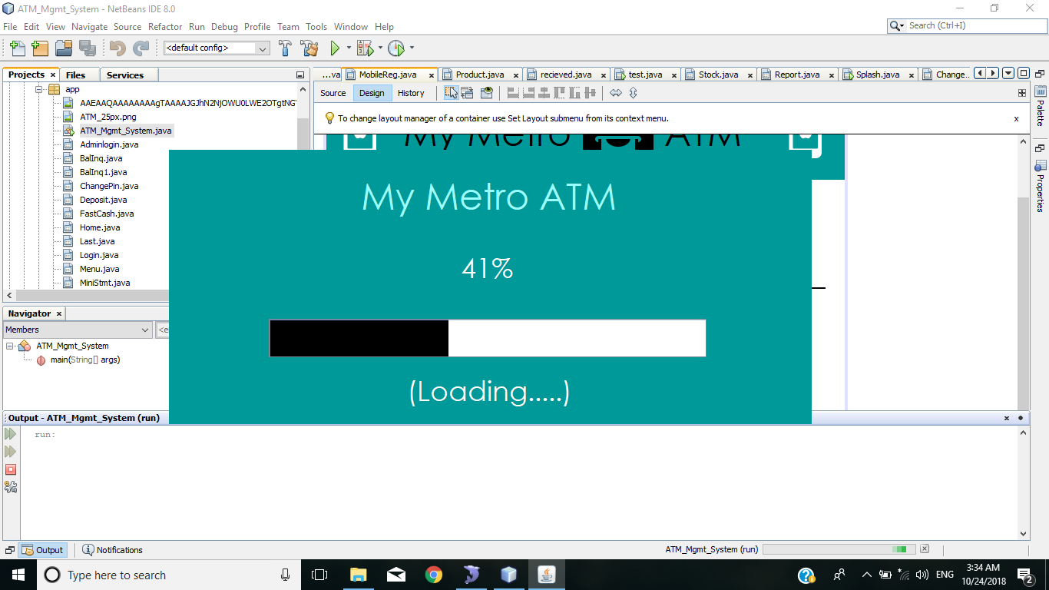

Picture for Home screen :

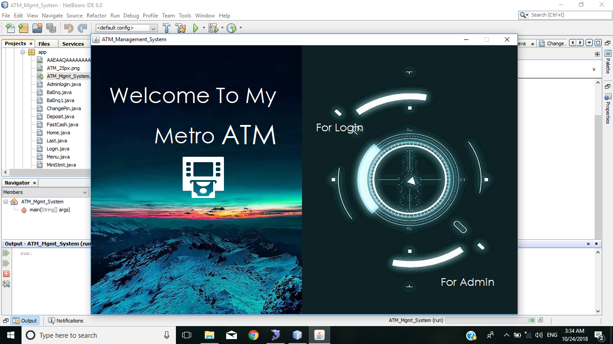

Picture for admin login :

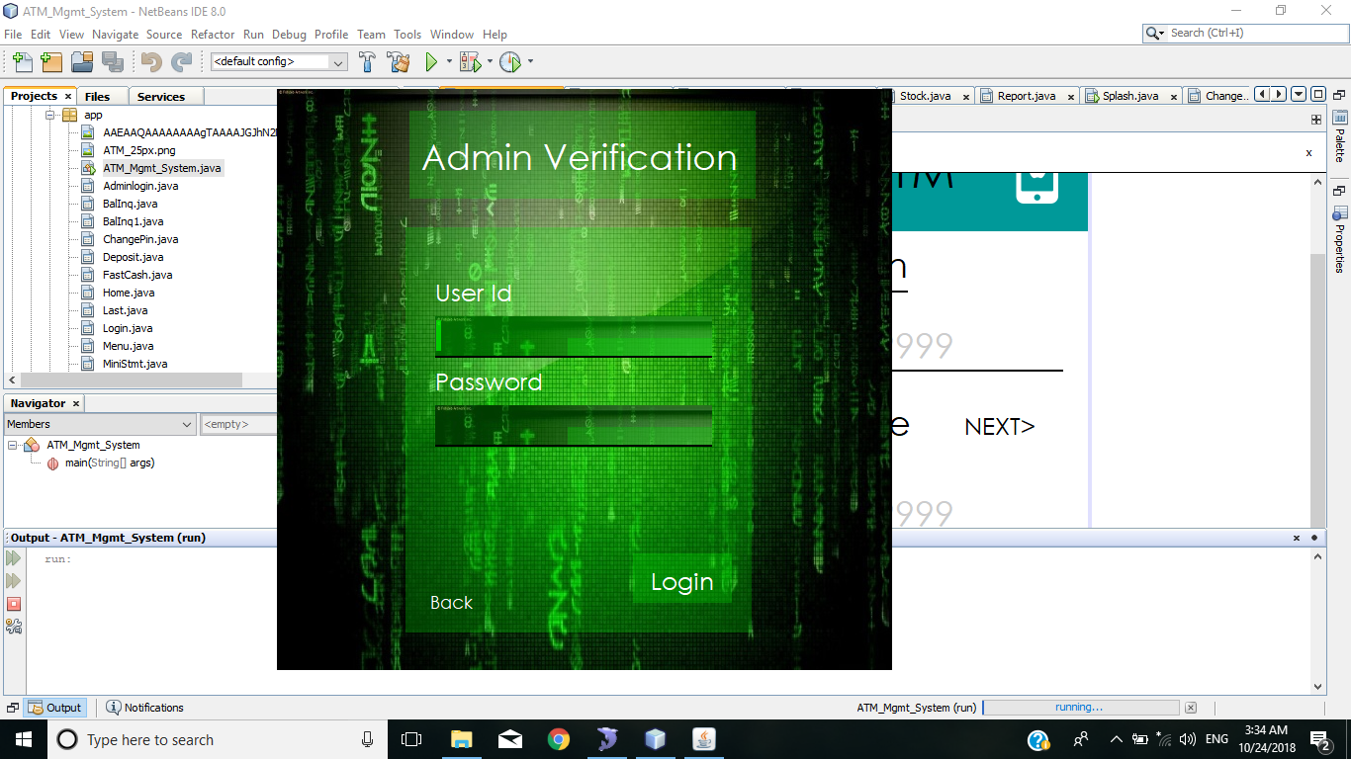

Picture for admin panel :

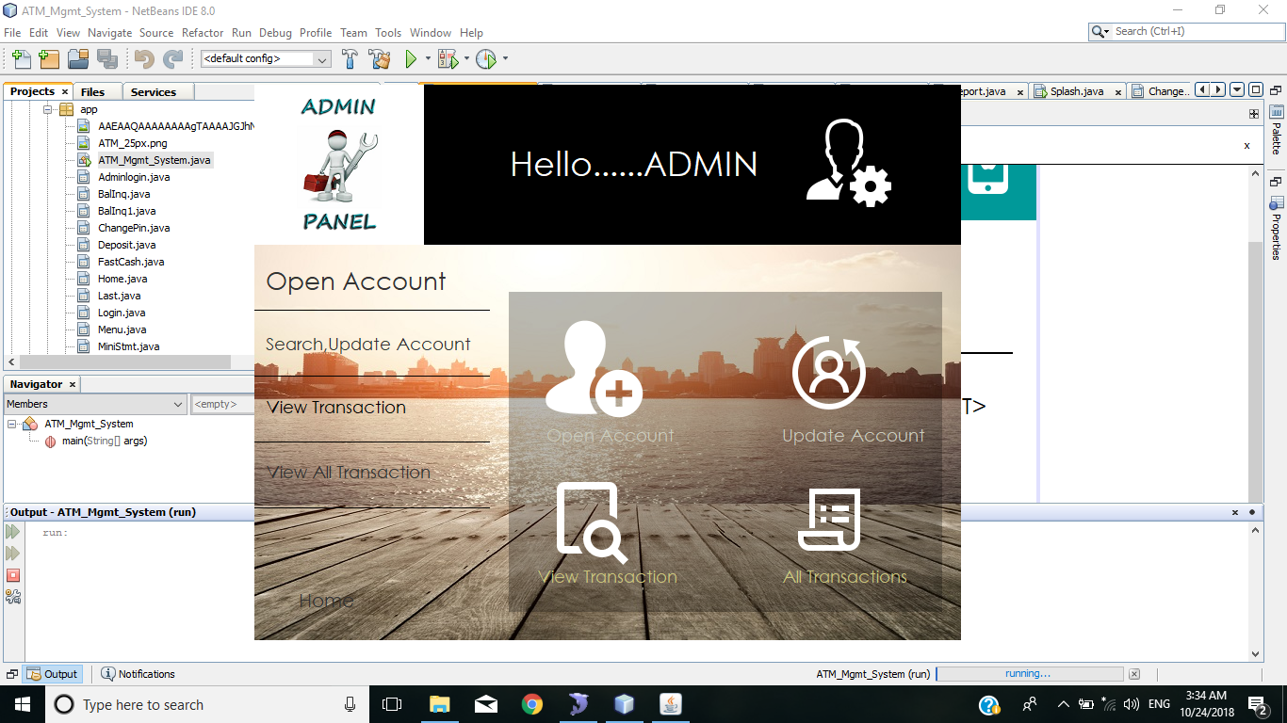

Picture for open account :

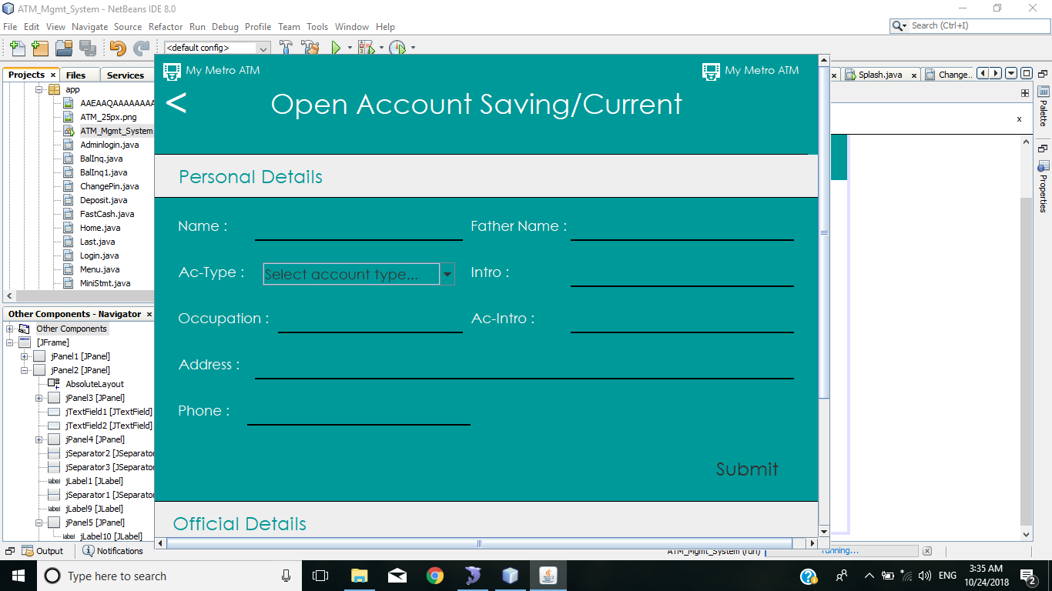

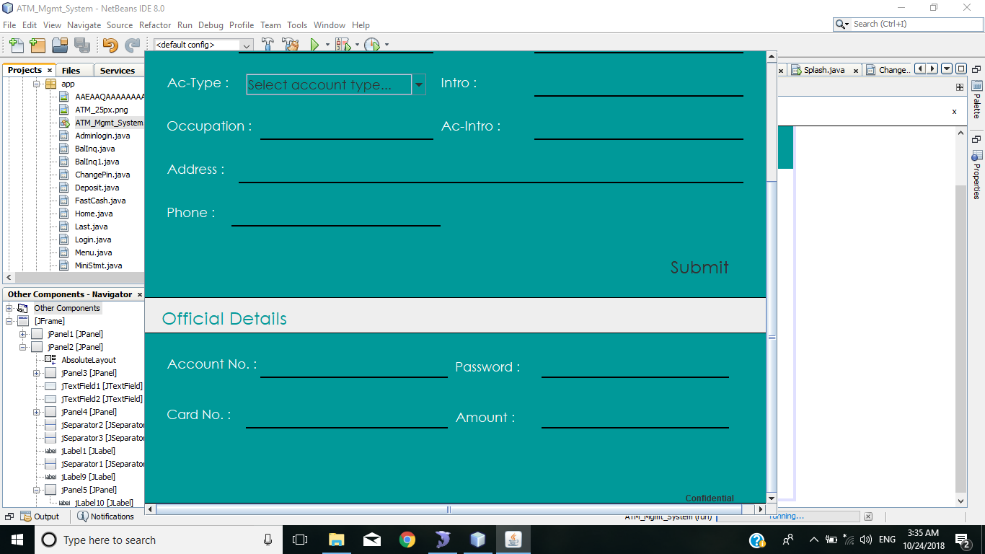

Picture for UPDATE ACCOUNT :

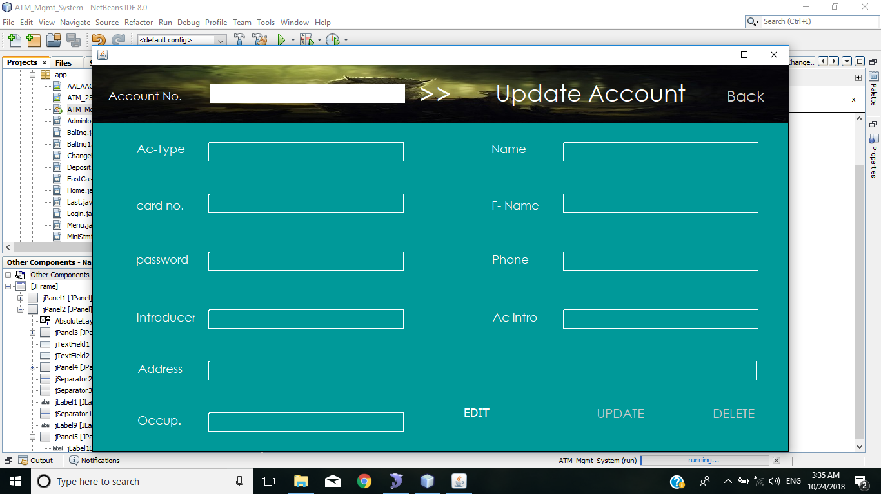

Picture for VIEW TRANSACTIONS :

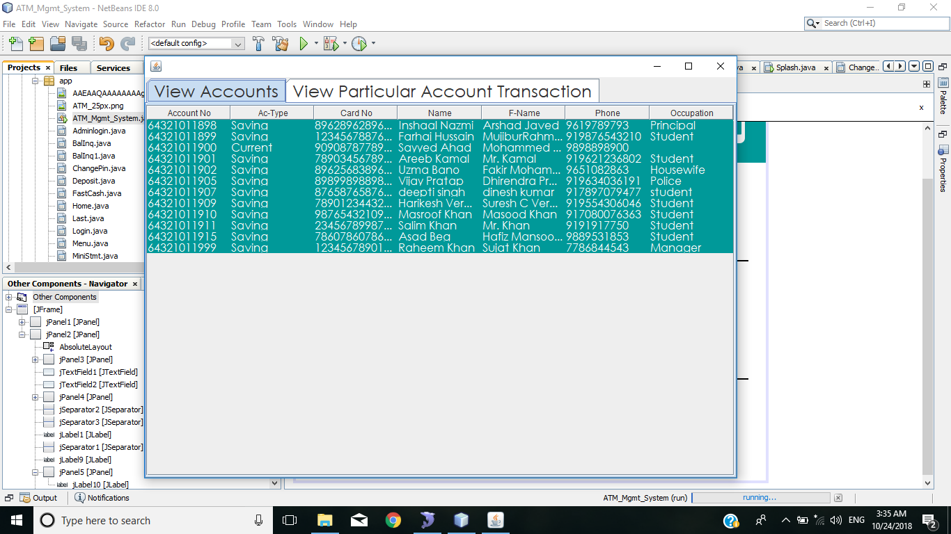

Picture for VIEW PARTICULAR ACCOUNT :

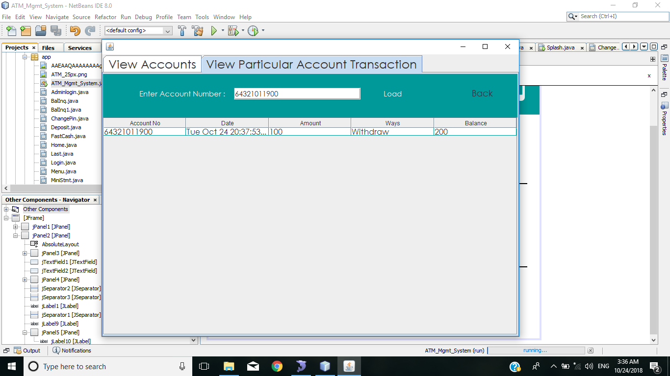

Picture for VIEW ALL TRANSACTIONS :

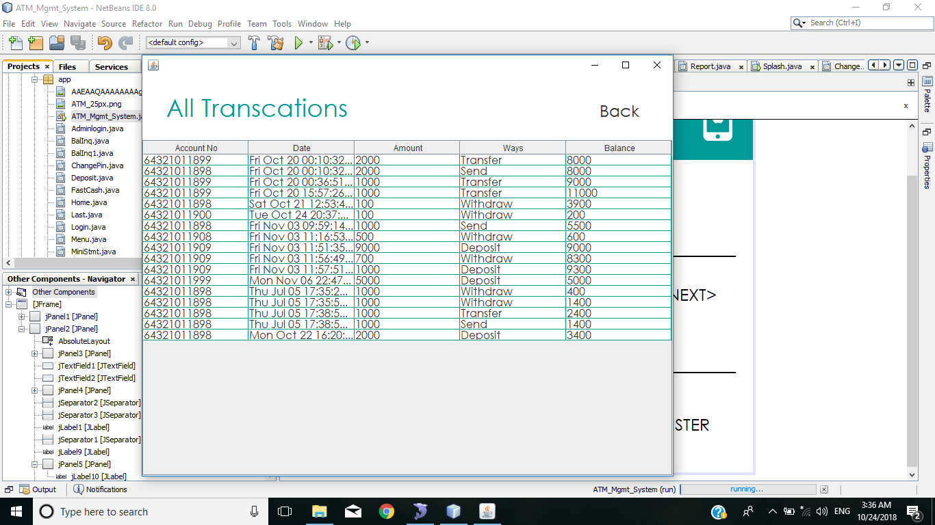

Picture for LOGIN :

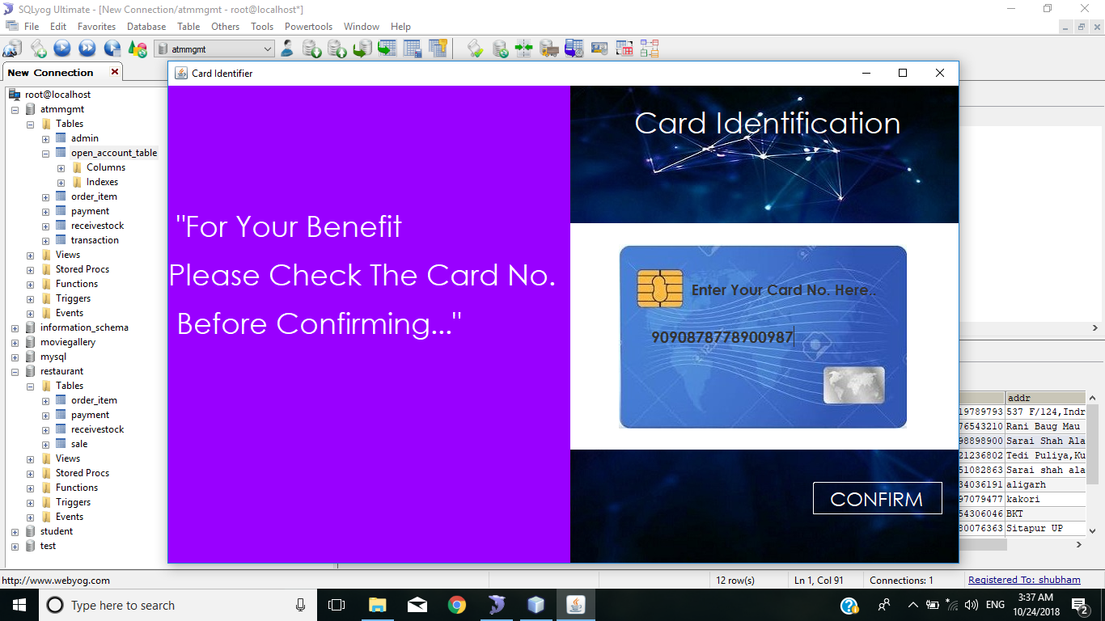

Picture for PIN:

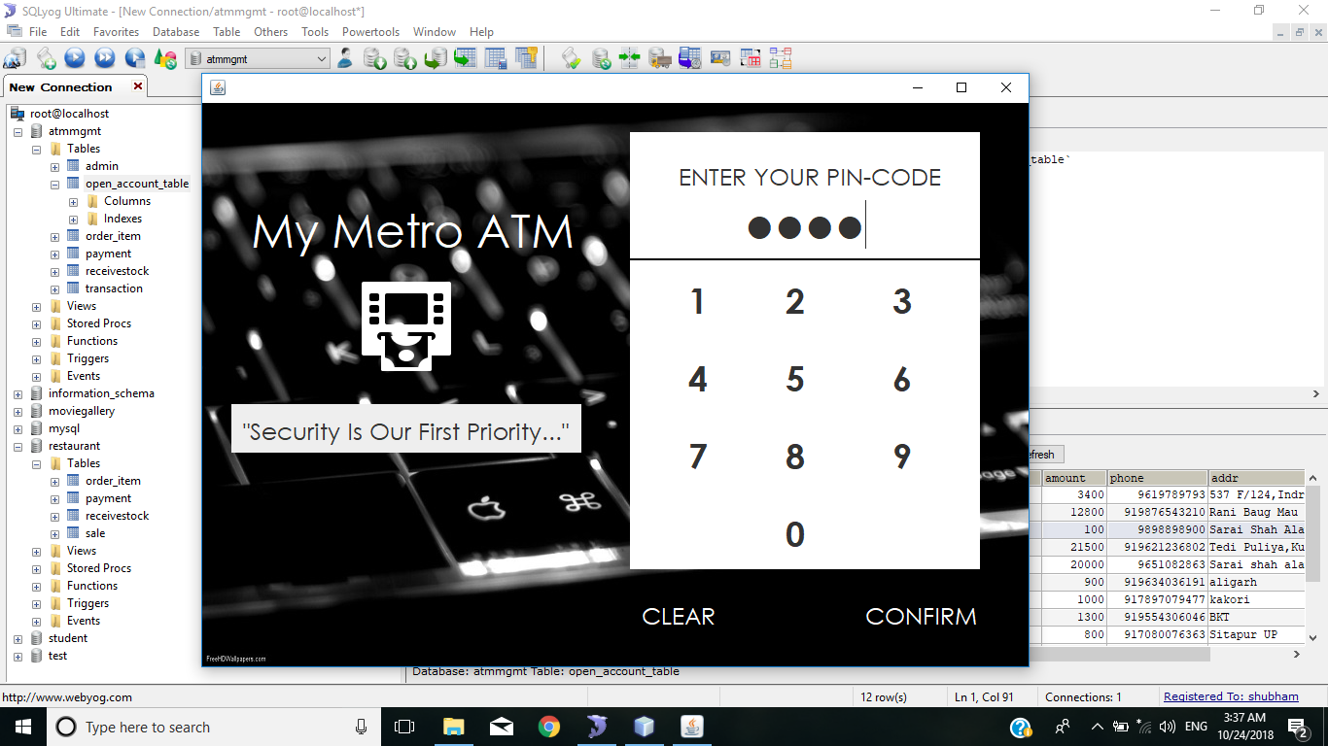

Picture for OTP :

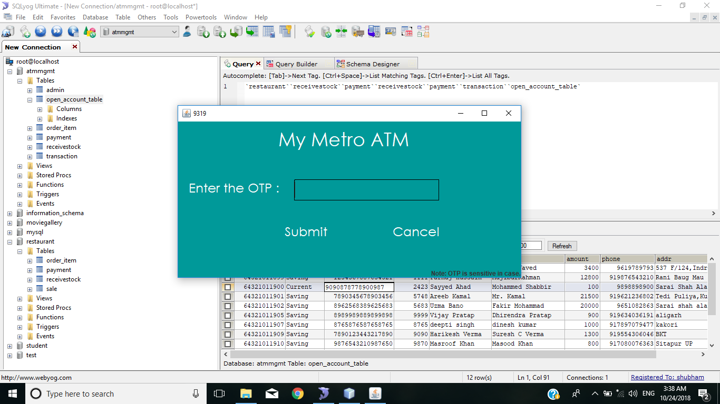

Picture for MENU :

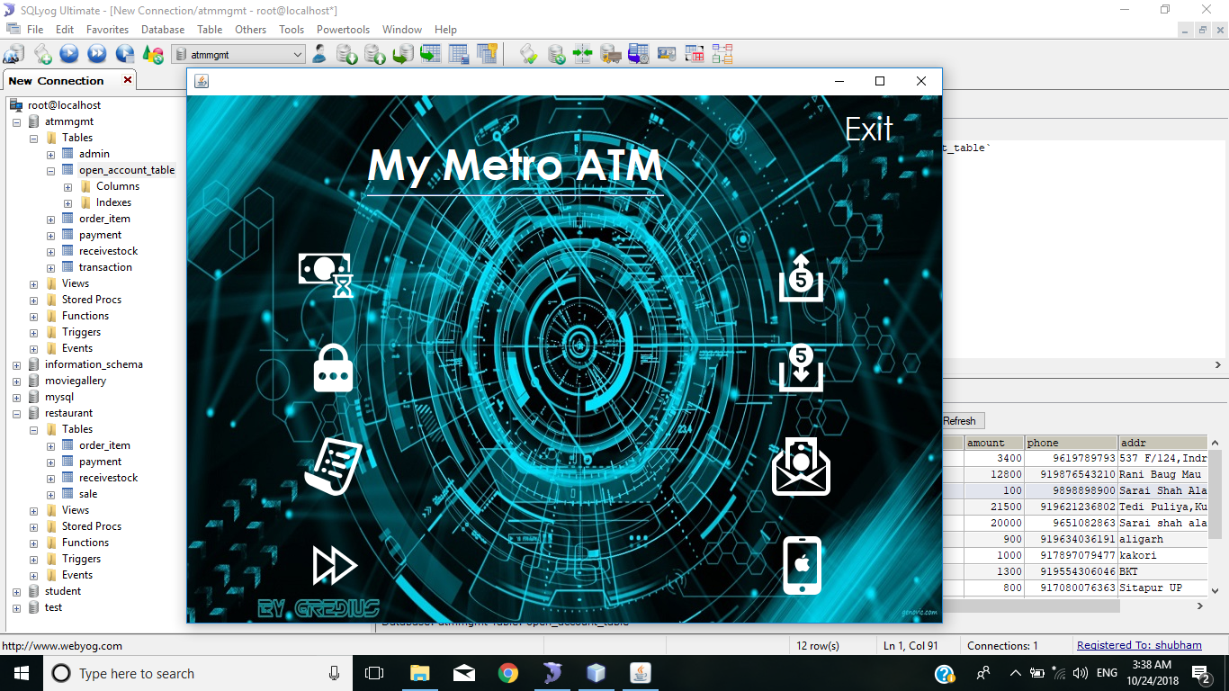

Picture for BALANCE INQUIRY :

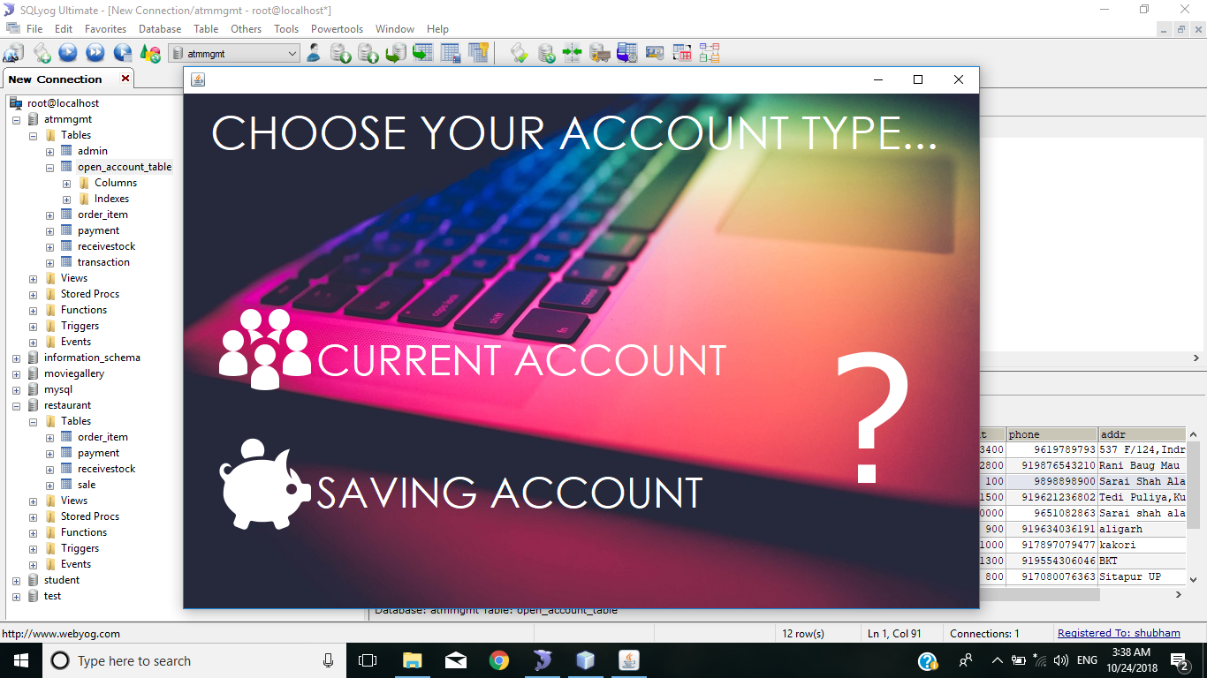

Picture for BALANCE INQUIRY 1 :

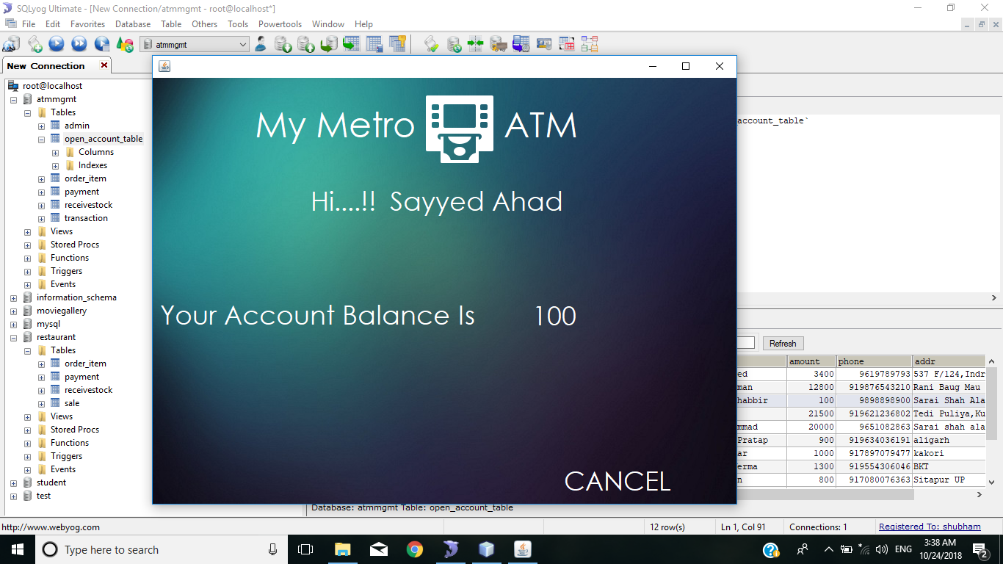

Picture for CHANGE PAASSWORD :

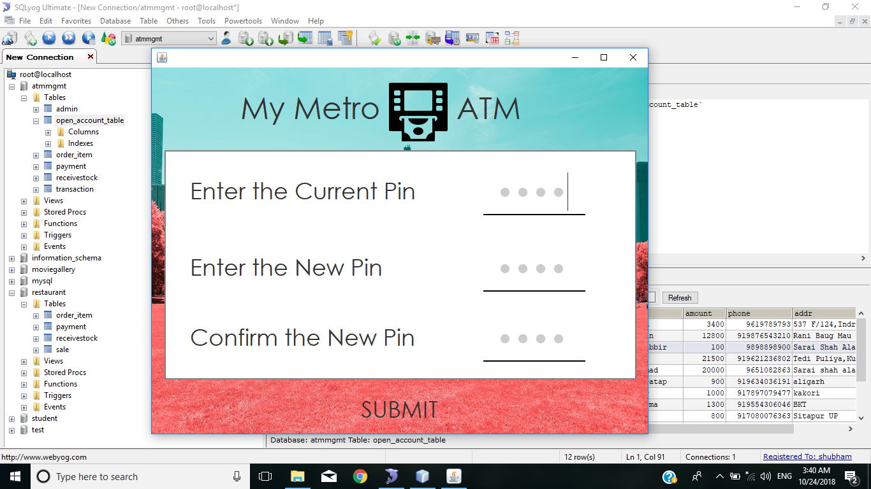

Picture for MINI STATEMENT :

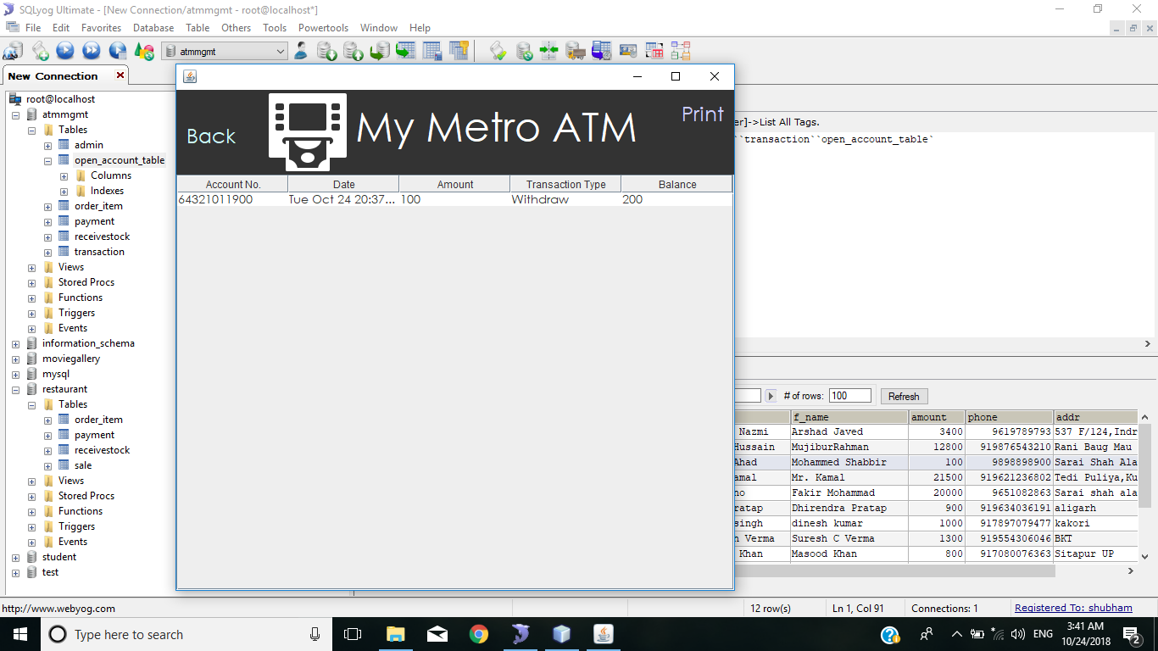

Picture for FAST CASH

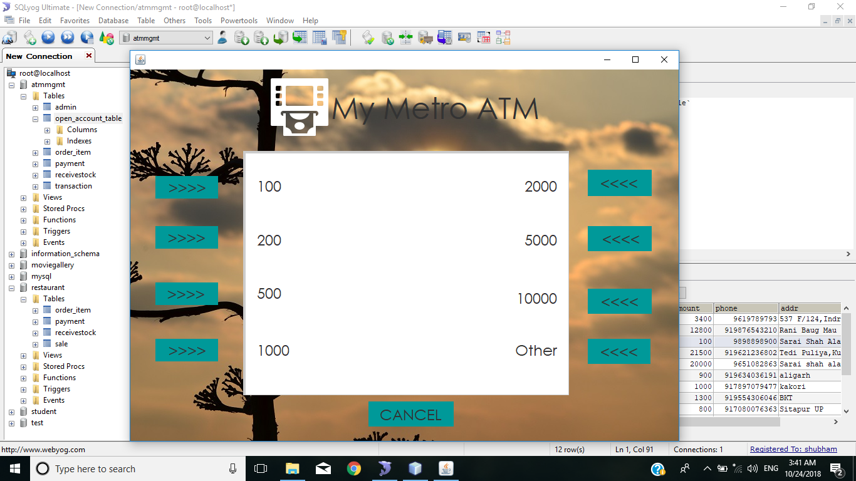

Picture for WITHDRAWAL :

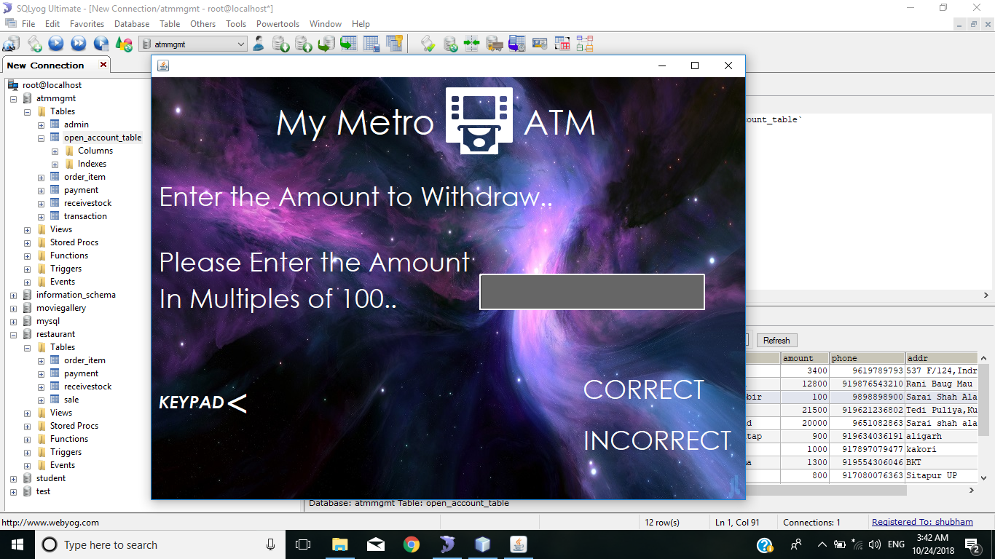

AMOUNT WITHDRWAL SUCCESSFULLY :

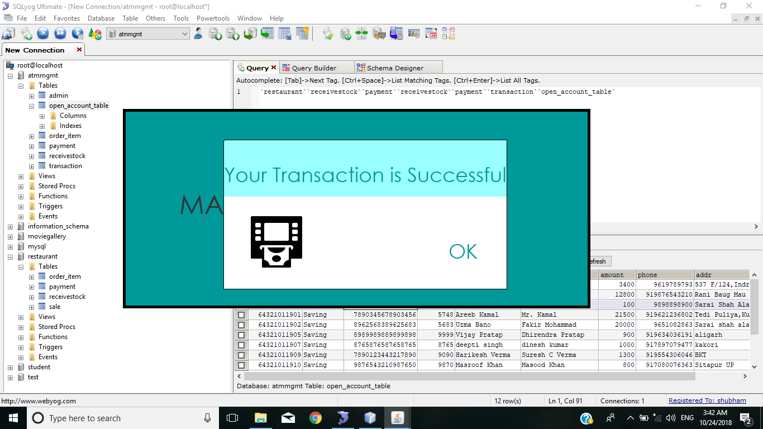

Picture for AMOUNT DEPOSITED:

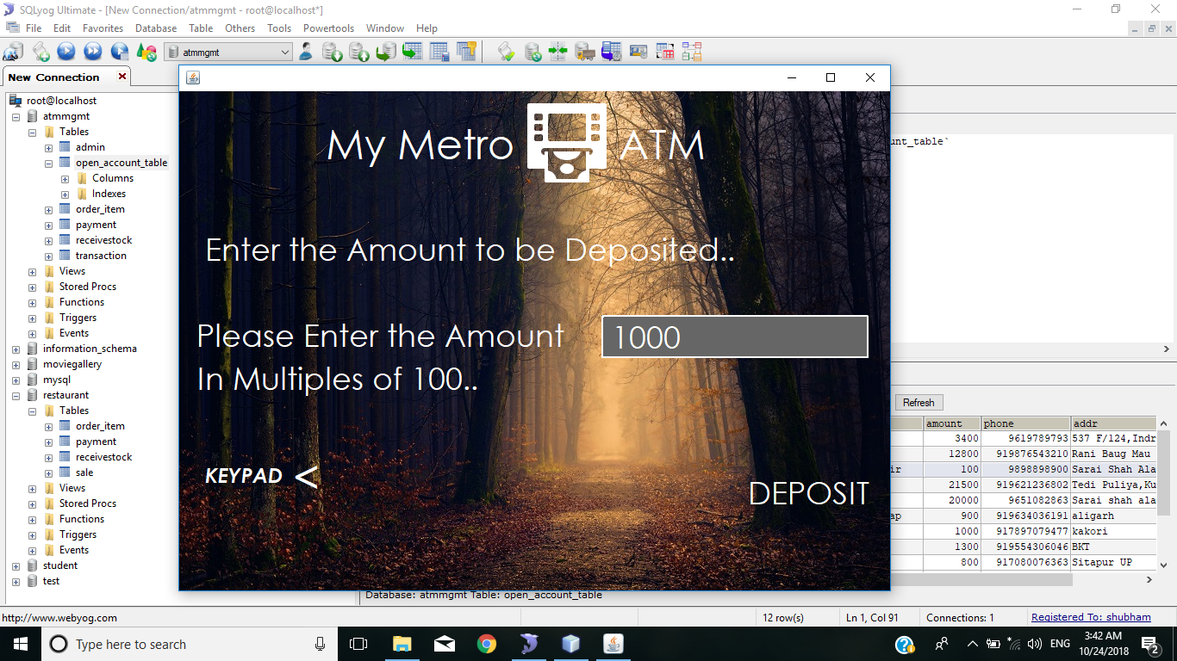

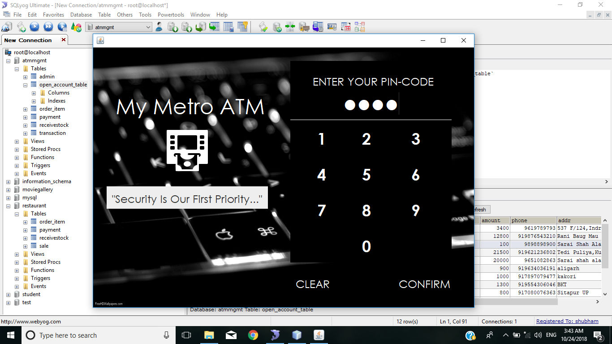

Picture for TRANSFER MONEY :

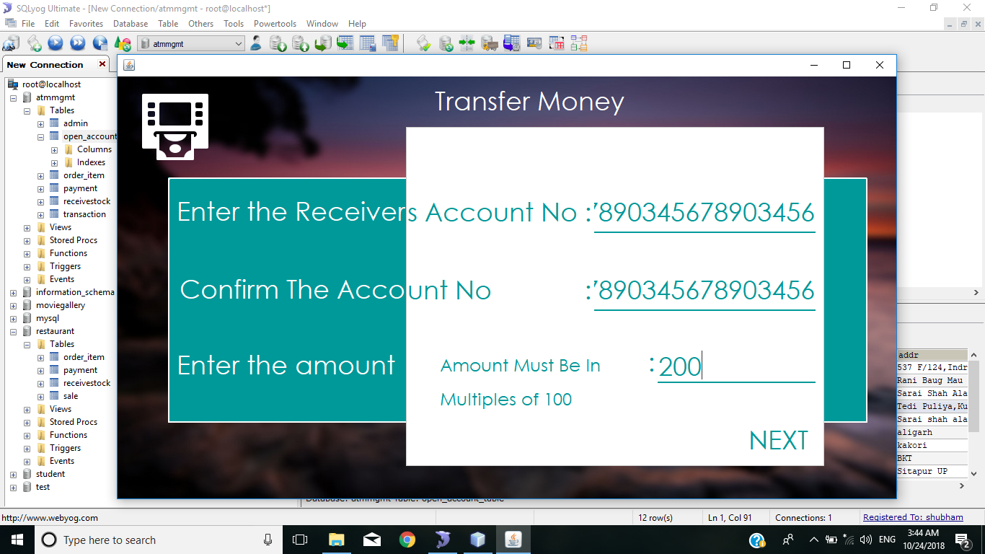

SSSSS

Picture for MOBILE REGISTRATION :

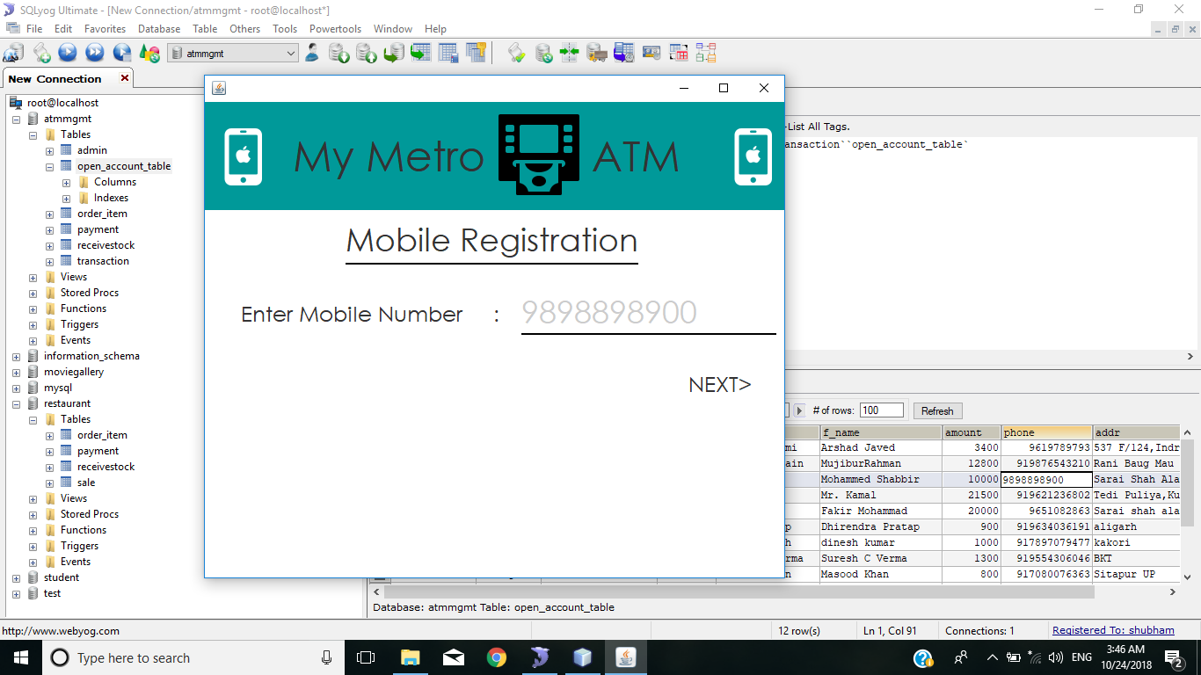

**FUTURE SCOPE AND ENHANCEMENT OF THE PROJECT**

This software is very flexibility to modify itself with the needs of users and customers in future. Yet the software is capable of enhancement.

Here we describe some features, which can be later introduced in the software for enhancing it.

We can add some new module like online payment gateways modules.

We can provide an authorization facility. Determining whether client is permitted to access the service. From which we can hide confidential information to the users.

More authentication responsibilities can be added in existing system through better automation offer.

We can improve several level of security.

We can add some extra utilities like notepad, online help etc, in my software.

CONCLUSION

The software will be developed by implementing the concept of modularity which in turn reduces the complexity involved in maintaining it. The administrator should have a sound technical knowledge about maintaining it. The administration should have a sound technical knowledge about maintaining the software and further enhancements will be undertaken by the developers.

The application is portable which ensure its adaptability for use on different computer terminals with different operating system and standards.

The factors guarantee the software’s availability includes proper terminal and correct input details. Also the resource used for the project development are Microsoft certified which speaks of its high quality standards.

Hence we may conclude that the application system being developed helps in modifying the computerized Restaurant Management.